ROCA
Religious Organization Calendar Application

Unified Technical Design Specification

Version 2.0
August 21, 2026
Status: Draft • Classification: Internal

Document Title | ROCA — Religious Organization Calendar Application
Version | 2.0 (Draft)
Date | August 21, 2026
Authors | Engineering Team
Status | Draft — Internal Review
Platform | Web (React) + Mobile (React Native iOS/Android)
Backend | Node.js/Express · PostgreSQL 15+

Table of Contents
Table of Contents 2
List of Figures 6
1. Introduction 6
1.1 Purpose 6
1.2 Scope 6
1.3 Intended Audience 6
1.4 Key Features Summary 7
2. System Architecture 7
2.1 Architecture Overview 7
2.2 Non-Functional Requirements Summary 7
3. Data Model 8
3.1 Design Principles 8
3.2 Entity Relationship Summary 8
4. Database Schema (Full SQL DDL) 9
4.1 Design Decisions 9
4.2 Complete SQL Schema 9
4.3 Index Strategy 13
5. API Design 14
5.1 Overview 14
5.2 RBAC Permission Matrix 14
5.3 Endpoint Reference 15
Authentication Endpoints (6) 15
Organizations & Campuses (8) 15
Rooms (5) 15
Members (6) 16
Events — Core Calendar (10) 16
Registrations / RSVP (5) 16
Event Categories (4) 17
Liturgical Seasons (5) 17
Scripture Readings (6) 17
Prayer Focuses (5) 18
Ministry Groups (8) 18
Volunteer Management (10) 18
Notifications, Search & Analytics 19
5.4 Error Codes 19
5.5 Rate Limiting 20
6. Web UI Wireframes 20
6.1 Design Principles 20
6.2 Screen 1: Dashboard / Home 21
6.3 Screen 2: Calendar View (Month) 21
6.4 Screen 3: Event Detail Flyout Panel 22
6.5 Screen 4: Volunteer Schedule View 23
6.6 Screen 5: Create / Edit Event Modal 24
7. Mobile Experience Design 26
7.1 Design Philosophy 26
7.2 Information Architecture (5-Tab Navigation) 26
7.3 Mobile Screen Wireframes 27
7.3.1 Home / Dashboard 27
7.3.2 Calendar Month View 28
7.3.3 Calendar Week View 28
7.3.4 Event Detail (Full Screen) 28
7.3.5 Serve / Volunteer Hub 29
7.3.6 Available Openings 30
7.3.7 Quick Add Bottom Sheet 30
7.3.8 Event Creation (4-Step Wizard) 30
7.3.9 Notifications Center 31
7.3.10 My Groups 32
7.4 Gesture & Interaction Patterns 32
7.5 Push Notification Strategy 33
7.6 Offline Mode Behavior 33
7.7 Liturgical Season Theming 33
7.8 Accessibility Features 34
8. User Flows 34
8.1 New Member Onboarding Flow 34
8.2 Event Discovery & RSVP Flow 34
8.3 Event Creation Flow (Leader / Admin / Pastor) 35
8.4 Volunteer Assignment & Confirmation Flow 35
8.5 Event Cancellation & Notification Flow 36
8.6 Scripture & Lectionary Management Flow 36
8.7 Recurring Event Management Flow 36
8.8 Push Notification Engagement Flow 37
9. State Diagrams 37
9.1 Event Lifecycle State Machine 37
9.2 Registration / RSVP State Machine 38
9.3 Volunteer Assignment State Machine 38
9.4 Member Account State Machine 38
9.5 Notification Delivery State Machine 39
9.6 Liturgical Season Annual Cycle 39
9.7 Auto-Scheduler Workflow States 39
10. Error Handling & Edge Cases 40
10.1 Conflict Resolution Matrix 40
10.2 Offline Sync State Machine 40
10.3 Session & Authentication Lifecycle 41
11. Non-Functional Requirements 41
11.1 Performance 41
11.2 Security 42
11.3 Availability & Reliability 42
11.4 Accessibility 42
11.5 Internationalization 43
12.12 Test Data Management 43
12.11 Acceptance Criteria & Definition of Done 44
12.10 Test Environments 44
12.9 CI/CD Pipeline Integration 45
12.8 Data Integrity Testing 46
12.7 Mobile-Specific Testing 46
12.6 Accessibility Testing 47
12.5 Security Testing 47
12.4 Performance Testing 48
12.3 End-to-End (E2E) Testing 48
12.2 Integration Testing 49
12.1 Unit Testing 50
12. Testing Strategy & Quality Assurance 50
13. Future Enhancements Roadmap 50
14. Appendix 50
14.1 RRULE Recurrence Examples 50
14.2 Glossary 51
14.3 Revision History 51
14.4 Complete App Navigation Map 51

List of Figures
Figure 1 Dashboard / Home — Web UI Mockup (Ordinary Time · August 2026) (§ 6.2)
Figure 2 Calendar View (Monthly) — Web UI Mockup (August 2026) (§ 6.3)
Figure 3 Event Detail Flyout Panel — Web UI Mockup (§ 6.4)
Figure 4 Volunteer Schedule View — Web UI Mockup (§ 6.5)
Figure 5 Create / Edit Event Modal (4-Step Wizard) — Web UI Mockup (§ 6.6)
Figure 6 Mobile Core Screens — Home, Calendar, Event Detail (iOS) (§ 7.3.1)
Figure 7 Mobile Serve Screens — My Schedule, Openings, Swap Requests (iOS) (§ 7.3.5)
Figure 8 Mobile Event Creation Wizard & Notifications / Groups (iOS) (§ 7.3.8)

1. Introduction

1.1 Purpose
This document consolidates the complete technical design for the Religious Organization Calendar Application (ROCA) — a purpose-built calendar and community management system for faith communities. It serves as the single authoritative reference covering database design, API architecture, web UI wireframes, mobile experience, user flows, and state machines.

1.2 Scope
ROCA is designed as a multi-tenant SaaS application supporting religious organizations of any denomination including churches, mosques, synagogues, and temples. The system encompasses:
- Web application (React 18+ / TypeScript)
- Native mobile applications (React Native for iOS and Android)
- RESTful API backend (Node.js/Express or FastAPI)
- PostgreSQL 15+ relational database
- Cloud deployment on AWS with OAuth 2.0/JWT authentication
- Push notifications via APNs (iOS) and FCM (Android)

1.3 Intended Audience
Audience | Primary Use of This Document
Software Engineers & Architects | Database implementation, API development, system integration
Product Managers | Feature scope definition, roadmap planning
QA Engineers | Test plan development, acceptance criteria
UX Designers | High-fidelity mockup creation from wireframes

1.4 Key Features Summary
Feature | Description
Event Management | Full CRUD with RFC 5545 recurrence, multi-campus room booking
Liturgical Calendar | Seasonal tracking with dynamic color theming across 8+ seasons
Volunteer Scheduling | Gap detection, auto-assignment with round-robin/weighted strategies, swap requests
RSVP Management | Capacity-aware registration, automatic waitlisting, CSV export
Scripture Integration | Lectionary import (RCL, Catholic, Lutheran), daily reading assignments
Role-Based Access | 7-tier RBAC: super_admin through guest, per-event visibility controls
Push Notifications | 9 notification types with deep linking, quiet hours, digest options
Offline-First Mobile | 24-hour cache, queue-and-sync writes, conflict resolution
Calendar Sync | iCal subscription, Google Calendar and Outlook export, PDF print
Analytics | Attendance trends, volunteer metrics, member engagement reporting

2. System Architecture

2.1 Architecture Overview
ROCA follows a three-tier architecture with clear separation between presentation, application logic, and data layers. The system is designed for horizontal scalability, multi-tenancy, and high availability.
Layer | Technology | Deployment
Web Frontend | React 18+, TypeScript, Tailwind CSS | CloudFront CDN + S3
Mobile Frontend | React Native, Expo | App Store / Google Play
Backend API | Node.js/Express (or FastAPI) | AWS ECS / Lambda
Database | PostgreSQL 15+ | AWS RDS Multi-AZ
Auth | OAuth 2.0 + JWT | Access: 15min TTL · Refresh: 7d
Search | PostgreSQL FTS + optional Elasticsearch | Embedded or AWS OpenSearch
File Storage | AWS S3 | Multi-region with CloudFront
CI/CD | GitHub Actions | ECS Blue/Green deployments

2.2 Non-Functional Requirements Summary
Metric | Target | Notes
Dashboard load (web) | < 1.5 seconds | p95 LCP
Calendar render (month) | < 800ms | including event dots
API response | < 300ms (p95) | excluding external calls
Mobile cold start | < 2 seconds | iOS and Android
Push notification delivery | < 5 seconds from trigger | APNs/FCM SLA dependent
Uptime SLA | 99.9% | excludes planned maintenance
Accessibility | WCAG 2.1 Level AA | Web + Mobile
Encryption (transit) | TLS 1.3 | All endpoints
Encryption (rest) | AES-256 | RDS + S3
Offline cache | 24 hours | Mobile, queue-and-sync writes

3. Data Model

3.1 Design Principles
Principle | Implementation
UUID Primary Keys | gen_random_uuid() for distributed ID generation; no sequential guessing of IDs
Multi-tenancy | org_id foreign key on every entity table; enforced at application and query layer
Soft Deletes | status/is_active columns preserve data for audit trails and undo capability
RFC 5545 Recurrence | RRULE format stored as VARCHAR; parsed at application layer for event expansion
Partial Indexes | Targeted indexes on recurring events, active statuses for query optimization
Timestamps | created_at and updated_at on all mutable tables; DEFAULT NOW() for consistency

3.2 Entity Relationship Summary
Entity | Key Relationships | Purpose
organizations | Parent of all entities | Multi-org/denomination support; top-level tenant
campuses | → organizations | Physical locations per organization
rooms | → campuses | Bookable rooms/facilities within each campus
members | → organizations | People directory, authentication, and role assignments
events | → org, categories, campuses, rooms | Core calendar entries with full recurrence support
event_categories | → organizations | Color-coded event groupings (Worship, Youth, etc.)
event_registrations | → events, members | RSVP tracking with capacity and waitlist management
liturgical_seasons | → organizations | Seasonal context, color theming, and scripture cycles
ministry_groups | → organizations, campuses | Small groups, committees, choirs, and ministry teams
group_members | → ministry_groups, members | Group roster with role assignments (leader, member)
scripture_readings | → organizations, events | Lectionary and daily reading assignments per event/date
prayer_focuses | → organizations | Weekly and daily prayer theme scheduling
volunteer_roles | → organizations | Role definitions (Greeter, Sound, Nursery) with min/max counts
volunteer_assignments | → events, roles, members | Volunteer scheduling per event and role
notifications | → organizations, events | Scheduled alerts, reminders, cancellations, and updates

4. Database Schema (Full SQL DDL)

4.1 Design Decisions
Decision | Rationale
UUID PKs via gen_random_uuid() | Prevents sequential ID enumeration; enables distributed generation without coordination
RFC 5545 RRULE for recurrence | Industry-standard format; supports all calendar applications and iCal export natively
Visibility enum on events | Simplifies role-based event filtering at the query layer; three-tier: public/members_only/leaders_only
Status-based soft deletes | Full audit trail; supports cancellation with reason; undo capability for accidental deletions
Partial index on is_recurring | Optimizes the most expensive query: expanding recurring series for calendar views
Separate recurrence_end_date | Enables efficient date range queries without parsing RRULE for boundary detection

4.2 Complete SQL Schema
-- =============================================
-- Religious Organization Calendar App
-- Database Schema (PostgreSQL 15+)
-- =============================================

-- ===================
-- CORE TABLES
-- ===================

-- Organizations (multi-church/mosque/synagogue support)
CREATE TABLE organizations (
org_id UUID PRIMARY KEY DEFAULT gen_random_uuid(),
name VARCHAR(255) NOT NULL,
denomination VARCHAR(100),
address TEXT,
city VARCHAR(100),
state VARCHAR(50),
zip VARCHAR(20),
phone VARCHAR(20),
email VARCHAR(255),
website VARCHAR(255),
timezone VARCHAR(50) NOT NULL DEFAULT 'America/New_York',
logo_url VARCHAR(500),
created_at TIMESTAMP DEFAULT NOW(),
updated_at TIMESTAMP DEFAULT NOW()
);

-- Campuses/Locations (multi-site support)
CREATE TABLE campuses (
campus_id UUID PRIMARY KEY DEFAULT gen_random_uuid(),
org_id UUID NOT NULL REFERENCES organizations(org_id),
name VARCHAR(255) NOT NULL,
address TEXT,
city VARCHAR(100),
state VARCHAR(50),
zip VARCHAR(20),
is_primary BOOLEAN DEFAULT FALSE,
accessibility_notes TEXT,
parking_info TEXT,
created_at TIMESTAMP DEFAULT NOW()
);

-- Rooms/Facilities within each campus
CREATE TABLE rooms (
room_id UUID PRIMARY KEY DEFAULT gen_random_uuid(),
campus_id UUID NOT NULL REFERENCES campuses(campus_id),
name VARCHAR(100) NOT NULL,
capacity INTEGER,
has_av_equipment BOOLEAN DEFAULT FALSE,
is_wheelchair_accessible BOOLEAN DEFAULT TRUE,
has_childcare_nearby BOOLEAN DEFAULT FALSE,
notes TEXT
);

-- ===================
-- PEOPLE & ROLES
-- ===================

CREATE TABLE members (
member_id UUID PRIMARY KEY DEFAULT gen_random_uuid(),
org_id UUID NOT NULL REFERENCES organizations(org_id),
first_name VARCHAR(100) NOT NULL,
last_name VARCHAR(100) NOT NULL,
email VARCHAR(255),
phone VARCHAR(20),
role VARCHAR(50) DEFAULT 'member',
-- pastor, admin, leader, volunteer, member
avatar_url VARCHAR(500),
is_active BOOLEAN DEFAULT TRUE,
created_at TIMESTAMP DEFAULT NOW()
);

-- ===================
-- CALENDAR & EVENTS
-- ===================

-- Liturgical Seasons
CREATE TABLE liturgical_seasons (
season_id UUID PRIMARY KEY DEFAULT gen_random_uuid(),
org_id UUID NOT NULL REFERENCES organizations(org_id),
name VARCHAR(100) NOT NULL,
-- Advent, Lent, Ordinary Time, etc.
color_hex VARCHAR(7),
start_date DATE NOT NULL,
end_date DATE NOT NULL,
description TEXT,
year INTEGER NOT NULL
);

-- Event Categories
CREATE TABLE event_categories (
category_id UUID PRIMARY KEY DEFAULT gen_random_uuid(),
org_id UUID NOT NULL REFERENCES organizations(org_id),
name VARCHAR(100) NOT NULL,
-- Worship, Youth, Outreach, Admin, etc.
color_hex VARCHAR(7) NOT NULL,
icon VARCHAR(50),
sort_order INTEGER DEFAULT 0
);

-- Events (core table)
CREATE TABLE events (
event_id UUID PRIMARY KEY DEFAULT gen_random_uuid(),
org_id UUID NOT NULL REFERENCES organizations(org_id),
category_id UUID REFERENCES event_categories(category_id),
campus_id UUID REFERENCES campuses(campus_id),
room_id UUID REFERENCES rooms(room_id),
title VARCHAR(255) NOT NULL,
description TEXT,
event_type VARCHAR(50) NOT NULL,
-- service, study, meeting, outreach, social, sacrament
start_datetime TIMESTAMP NOT NULL,
end_datetime TIMESTAMP NOT NULL,
is_all_day BOOLEAN DEFAULT FALSE,
is_recurring BOOLEAN DEFAULT FALSE,
recurrence_rule VARCHAR(255), -- RRULE format (RFC 5545)
recurrence_end_date DATE,
max_capacity INTEGER,
requires_rsvp BOOLEAN DEFAULT FALSE,
registration_url VARCHAR(500),
livestream_url VARCHAR(500),
childcare_available BOOLEAN DEFAULT FALSE,
contact_member_id UUID REFERENCES members(member_id),
visibility VARCHAR(20) DEFAULT 'public',
-- public, members_only, leaders_only
status VARCHAR(20) DEFAULT 'active',
-- active, cancelled, postponed
cancellation_reason TEXT,
created_by UUID REFERENCES members(member_id),
created_at TIMESTAMP DEFAULT NOW(),
updated_at TIMESTAMP DEFAULT NOW()
);

-- Event RSVPs/Registrations
CREATE TABLE event_registrations (
registration_id UUID PRIMARY KEY DEFAULT gen_random_uuid(),
event_id UUID NOT NULL REFERENCES events(event_id),
member_id UUID REFERENCES members(member_id),
guest_name VARCHAR(200),
guest_email VARCHAR(255),
party_size INTEGER DEFAULT 1,
status VARCHAR(20) DEFAULT 'registered',
-- registered, waitlisted, cancelled
notes TEXT,
registered_at TIMESTAMP DEFAULT NOW()
);

-- ===================
-- MINISTRY & GROUPS
-- ===================

CREATE TABLE ministry_groups (
group_id UUID PRIMARY KEY DEFAULT gen_random_uuid(),
org_id UUID NOT NULL REFERENCES organizations(org_id),
name VARCHAR(255) NOT NULL,
description TEXT,
group_type VARCHAR(50),
-- small_group, ministry, committee, choir, class
leader_member_id UUID REFERENCES members(member_id),
meeting_day VARCHAR(10),
meeting_time TIME,
campus_id UUID REFERENCES campuses(campus_id),
is_active BOOLEAN DEFAULT TRUE
);

CREATE TABLE group_members (
group_id UUID NOT NULL REFERENCES ministry_groups(group_id),
member_id UUID NOT NULL REFERENCES members(member_id),
role VARCHAR(50) DEFAULT 'member',
-- leader, co-leader, member
joined_at TIMESTAMP DEFAULT NOW(),
PRIMARY KEY (group_id, member_id)
);

-- ===================
-- SPIRITUAL CONTENT
-- ===================

CREATE TABLE scripture_readings (
reading_id UUID PRIMARY KEY DEFAULT gen_random_uuid(),
org_id UUID NOT NULL REFERENCES organizations(org_id),
event_id UUID REFERENCES events(event_id),
reading_date DATE NOT NULL,
reading_type VARCHAR(50),
-- first_reading, psalm, gospel, epistle
reference VARCHAR(100) NOT NULL, -- e.g. "John 3:16-21"
text_content TEXT,
sort_order INTEGER DEFAULT 0
);

CREATE TABLE prayer_focuses (
prayer_id UUID PRIMARY KEY DEFAULT gen_random_uuid(),
org_id UUID NOT NULL REFERENCES organizations(org_id),
title VARCHAR(255) NOT NULL,
description TEXT,
start_date DATE NOT NULL,
end_date DATE NOT NULL,
prayer_type VARCHAR(50)
-- weekly, daily, special
);

-- ===================
-- VOLUNTEER SCHEDULING
-- ===================

CREATE TABLE volunteer_roles (
role_id UUID PRIMARY KEY DEFAULT gen_random_uuid(),
org_id UUID NOT NULL REFERENCES organizations(org_id),
name VARCHAR(100) NOT NULL,
-- Greeter, Usher, Sound Tech, Nursery, etc.
description TEXT,
min_volunteers INTEGER DEFAULT 1,
max_volunteers INTEGER
);

CREATE TABLE volunteer_assignments (
assignment_id UUID PRIMARY KEY DEFAULT gen_random_uuid(),
event_id UUID NOT NULL REFERENCES events(event_id),
role_id UUID NOT NULL REFERENCES volunteer_roles(role_id),
member_id UUID NOT NULL REFERENCES members(member_id),
status VARCHAR(20) DEFAULT 'assigned',
-- assigned, confirmed, declined, swapped
notes TEXT,
assigned_at TIMESTAMP DEFAULT NOW()
);

-- ===================
-- NOTIFICATIONS & ALERTS
-- ===================

CREATE TABLE notifications (
notification_id UUID PRIMARY KEY DEFAULT gen_random_uuid(),
org_id UUID NOT NULL REFERENCES organizations(org_id),
event_id UUID REFERENCES events(event_id),
title VARCHAR(255) NOT NULL,
message TEXT NOT NULL,
notification_type VARCHAR(50),
-- reminder, cancellation, update, weather_alert
send_at TIMESTAMP,
sent BOOLEAN DEFAULT FALSE,
created_at TIMESTAMP DEFAULT NOW()
);

-- ===================
-- INDEXES
-- ===================

CREATE INDEX idx_events_org_date
ON events(org_id, start_datetime);

CREATE INDEX idx_events_category
ON events(category_id);

CREATE INDEX idx_events_campus
ON events(campus_id);

CREATE INDEX idx_events_recurring
ON events(is_recurring) WHERE is_recurring = TRUE;

CREATE INDEX idx_registrations_event
ON event_registrations(event_id);

CREATE INDEX idx_liturgical_season_dates
ON liturgical_seasons(org_id, start_date, end_date);

CREATE INDEX idx_volunteer_event
ON volunteer_assignments(event_id);

CREATE INDEX idx_scripture_date
ON scripture_readings(org_id, reading_date);

4.3 Index Strategy
Index | Table | Purpose
idx_events_org_date | events | Primary calendar query — events by org + date range
idx_events_category | events | Filter calendar view by event category
idx_events_campus | events | Filter events by campus for multi-site views
idx_events_recurring (partial) | events | Optimize recurring event expansion (WHERE is_recurring = TRUE)
idx_registrations_event | event_registrations | RSVP count and roster lookups per event
idx_liturgical_season_dates | liturgical_seasons | Current season detection and date range queries
idx_volunteer_event | volunteer_assignments | Volunteer grid lookups per event
idx_scripture_date | scripture_readings | Daily readings lookup by org and date

5. API Design

5.1 Overview
Property | Value
Base URL | /api/v1/
Authentication | OAuth 2.0 + JWT Bearer Token
Content-Type | application/json
Total Endpoints | 75+ across 14 resource groups
Token TTL | Access: 15 minutes · Refresh: 7 days
Versioning | URI path (/api/v1/) with 6-month Sunset header deprecation

5.2 RBAC Permission Matrix
Seven roles govern access throughout the system. Permissions are additive — higher roles inherit all lower-role capabilities. The asterisk (*) denotes scope-limited access (e.g., leaders manage only their ministry group or campus).
Resource / Action | guest | member | vol. | leader | admin | pastor
Public events (read) | ✓ | ✓ | ✓ | ✓ | ✓ | ✓
Member events (read) | ✗ | ✓ | ✓ | ✓ | ✓ | ✓
Leaders-only events (read) | ✗ | ✗ | ✗ | ✓ | ✓ | ✓
Events (create/edit) | ✗ | ✗ | ✗ | ✓* | ✓ | ✓
Events (delete/cancel) | ✗ | ✗ | ✗ | ✗ | ✓ | ✓
RSVP / Registrations | ✗ | ✓ | ✓ | ✓ | ✓ | ✓
Volunteer assignments (view own) | ✗ | ✗ | ✓ | ✓ | ✓ | ✓
Volunteer assignments (assign) | ✗ | ✗ | ✗ | ✓* | ✓ | ✓
Scripture readings (manage) | ✗ | ✗ | ✗ | ✗ | ✗ | ✓
Members (manage) | ✗ | ✗ | ✗ | ✗ | ✓ | ✓
Org settings | ✗ | ✗ | ✗ | ✗ | ✓ | ✓
Analytics & Reporting | ✗ | ✗ | ✗ | ✗ | ✓ | ✓
✓* = Scope-limited to the leader's ministry group or campus assignment.

5.3 Endpoint Reference

Authentication Endpoints (6)
Method | Path | Access | Description
POST | /api/v1/auth/register | PUBLIC | Register new member (pending admin approval)
POST | /api/v1/auth/login | PUBLIC | Authenticate and receive JWT + refresh token
POST | /api/v1/auth/refresh | Authenticated | Exchange refresh token for new access token
POST | /api/v1/auth/logout | Authenticated | Revoke refresh token
POST | /api/v1/auth/forgot-password | PUBLIC | Initiate password reset flow
POST | /api/v1/auth/reset-password | PUBLIC | Complete password reset with token

Organizations & Campuses (8)
Method | Path | Access | Description
GET | /api/v1/organizations | super_admin | List all organizations (platform level)
GET | /api/v1/organizations/{org_id} | member+ | Get organization details
PUT | /api/v1/organizations/{org_id} | admin, pastor | Update organization settings
GET | /api/v1/campuses | member+ | List all campuses for authenticated org
POST | /api/v1/campuses | admin, pastor | Create a new campus
GET | /api/v1/campuses/{campus_id} | member+ | Get campus details including rooms
PUT | /api/v1/campuses/{campus_id} | admin, pastor | Update campus information
DELETE | /api/v1/campuses/{campus_id} | admin, pastor | Deactivate a campus (soft delete)

Rooms (5)
Method | Path | Access | Description
GET | /api/v1/campuses/{id}/rooms | member+ | List rooms for a campus (filterable by capacity, AV, accessibility)
POST | /api/v1/campuses/{id}/rooms | admin, pastor | Add a room to a campus
GET | /api/v1/rooms/{room_id} | member+ | Get room details
PUT | /api/v1/rooms/{room_id} | admin, pastor | Update room details
GET | /api/v1/rooms/{room_id}/availability | leader+ | Check room availability for a date range

Members (6)
Method | Path | Access | Description
GET | /api/v1/members | leader+ (scoped), admin | List members filtered by role, group, or search
GET | /api/v1/members/{member_id} | self / leader+ / admin | Get member profile (detail level by role)
PUT | /api/v1/members/{member_id} | self / admin, pastor | Update member profile
DELETE | /api/v1/members/{member_id} | admin, pastor | Deactivate a member (soft delete)
GET | /api/v1/members/me | Authenticated | Get current authenticated member's profile
GET | /api/v1/members/me/events | Authenticated | Get events registered for, assigned to, or leading

Events — Core Calendar (10)
Method | Path | Access | Description
GET | /api/v1/events | guest/member+ (by visibility) | List events with filtering, search, pagination
POST | /api/v1/events | leader+ (scoped), admin, pastor | Create a new event
GET | /api/v1/events/{event_id} | based on event visibility | Full event detail with registration count, volunteers, scripture
PUT | /api/v1/events/{event_id} | leader+ / admin, pastor | Update an event (supports update_scope for recurring)
DELETE | /api/v1/events/{event_id} | admin, pastor | Cancel or delete an event (scope param for recurring)
POST | /api/v1/events/{event_id}/cancel | admin, pastor | Cancel event and send notifications to attendees
POST | /api/v1/events/{event_id}/duplicate | leader+, admin, pastor | Clone an event to a new date
GET | /api/v1/events/upcoming | member+ | Dashboard convenience: next N days of events
POST | /api/v1/events/conflicts | leader+ | Check for scheduling conflicts before creating
GET | /api/v1/events/export/ical | member+ | Export events as subscribable iCal feed

Registrations / RSVP (5)
Method | Path | Access | Description
GET | /api/v1/events/{id}/registrations | leader+, admin, pastor | List all RSVPs; includes total, waitlisted, spots remaining
POST | /api/v1/events/{id}/registrations | member+ | RSVP to event; auto-waitlists if at capacity
PUT | /api/v1/events/{id}/registrations/{rid} | self / admin, pastor | Update party size or notes
DELETE | /api/v1/events/{id}/registrations/{rid} | self / admin, pastor | Cancel registration; auto-promotes first waitlisted
GET | /api/v1/events/{id}/registrations/export | leader+, admin, pastor | Export registration list as CSV

Event Categories (4)
Method | Path | Access | Description
GET | /api/v1/categories | member+ | List all event categories
POST | /api/v1/categories | admin, pastor | Create a new category with color and icon
PUT | /api/v1/categories/{category_id} | admin, pastor | Update a category
DELETE | /api/v1/categories/{category_id} | admin, pastor | Delete category (409 if events exist)

Liturgical Seasons (5)
Method | Path | Access | Description
GET | /api/v1/liturgical-seasons | member+ | List seasons for a year with current season context
GET | /api/v1/liturgical-seasons/current | PUBLIC | Get current season with color, week number, and description
POST | /api/v1/liturgical-seasons | pastor | Define a liturgical season
PUT | /api/v1/liturgical-seasons/{season_id} | pastor | Update a season
POST | /api/v1/liturgical-seasons/generate | pastor | Auto-generate seasons by denomination template (catholic, lutheran, anglican, orthodox, custom)

Scripture Readings (6)
Method | Path | Access | Description
GET | /api/v1/scripture-readings | member+ | List readings for a date range, optionally filtered by type
GET | /api/v1/scripture-readings/today | PUBLIC | Today's scripture readings
POST | /api/v1/scripture-readings | pastor | Assign a scripture reading to an event or date
PUT | /api/v1/scripture-readings/{reading_id} | pastor | Update a reading assignment
DELETE | /api/v1/scripture-readings/{reading_id} | pastor | Remove a reading
POST | /api/v1/scripture-readings/import | pastor | Bulk import lectionary (RCL, Catholic, Lutheran) for a year/cycle

Prayer Focuses (5)
Method | Path | Access | Description
GET | /api/v1/prayer-focuses | member+ | List prayer focuses by date range and type
GET | /api/v1/prayer-focuses/current | PUBLIC | Get the current active prayer focus
POST | /api/v1/prayer-focuses | pastor, admin | Create a prayer focus
PUT | /api/v1/prayer-focuses/{prayer_id} | pastor, admin | Update a prayer focus
DELETE | /api/v1/prayer-focuses/{prayer_id} | pastor, admin | Delete a prayer focus

Ministry Groups (8)
Method | Path | Access | Description
GET | /api/v1/groups | member+ | List groups filtered by type, campus, and active status
POST | /api/v1/groups | admin, pastor | Create a ministry group
GET | /api/v1/groups/{group_id} | member+ | Group details with member roster and upcoming events
PUT | /api/v1/groups/{group_id} | group leader, admin, pastor | Update group information
DELETE | /api/v1/groups/{group_id} | admin, pastor | Deactivate a group
POST | /api/v1/groups/{id}/members | group leader, admin, pastor | Add a member to a group
PUT | /api/v1/groups/{id}/members/{mid} | group leader, admin, pastor | Update member role within group
DELETE | /api/v1/groups/{id}/members/{mid} | self / group leader / admin | Remove a member from a group

Volunteer Management (10)
Method | Path | Access | Description
GET | /api/v1/volunteer-roles | member+ | List all defined volunteer roles
POST | /api/v1/volunteer-roles | admin, pastor | Create a volunteer role with min/max counts
PUT | /api/v1/volunteer-roles/{role_id} | admin, pastor | Update a volunteer role
DELETE | /api/v1/volunteer-roles/{role_id} | admin, pastor | Delete role (409 if active assignments)
GET | /api/v1/volunteer-assignments | volunteer+ (scoped) | List assignments with has_gaps filter
POST | /api/v1/volunteer-assignments | leader+, admin, pastor | Create a volunteer assignment; notifies assignee
PUT | /api/v1/volunteer-assignments/{id} | assigned volunteer / leader+ | Update status: confirm, decline, or swap
DELETE | /api/v1/volunteer-assignments/{id} | leader+, admin, pastor | Remove an assignment
GET | /api/v1/volunteer-assignments/gaps | leader+, admin, pastor | Find events with unfilled volunteer positions
POST | /api/v1/volunteer-assignments/auto-schedule | admin, pastor | Auto-generate schedule draft (round-robin, weighted, preference-based)

Notifications, Search & Analytics
Method | Path | Access | Description
GET | /api/v1/notifications | Authenticated | List notifications for current user (with read filter)
POST | /api/v1/notifications | admin, pastor | Create and schedule a notification for an audience
POST | /api/v1/notifications/{id}/read | Authenticated | Mark notification as read
POST | /api/v1/notifications/read-all | Authenticated | Mark all notifications as read
GET | /api/v1/search | member+ | Full-text search across events, groups, and members
GET | /api/v1/analytics/attendance | admin, pastor | Attendance trends by event type and granularity
GET | /api/v1/analytics/volunteers | admin, pastor | Volunteer participation metrics and top contributors
GET | /api/v1/analytics/growth | admin, pastor | Member growth and event engagement rates
POST | /api/v1/webhooks | admin | Register webhook for 11 subscribable event types
DELETE | /api/v1/webhooks/{id} | admin | Unregister a webhook endpoint

5.4 Error Codes
Code | HTTP Status | Message
AUTH_001 | 401 | Invalid or expired access token
AUTH_002 | 403 | Insufficient permissions for this action
AUTH_003 | 403 | Resource not visible at your access level
EVENT_001 | 404 | Event not found
EVENT_002 | 409 | Scheduling conflict detected
EVENT_003 | 422 | Invalid recurrence rule format (RRULE)
REG_001 | 409 | Event has reached maximum capacity
REG_002 | 409 | Member is already registered for this event
VOL_001 | 409 | Volunteer already assigned to this role for this event
VOL_002 | 409 | Maximum volunteer count reached for this role
ROOM_001 | 409 | Room is already booked for this time slot
GENERAL_001 | 400 | Invalid request body or missing required fields
GENERAL_002 | 429 | Rate limit exceeded — see X-RateLimit-Reset header
GENERAL_003 | 500 | Internal server error

5.5 Rate Limiting
Role Tier | Request Limit | Window | Response Headers
guest | 30 req/min | Rolling 60s | X-RateLimit-Limit, -Remaining, -Reset
member | 100 req/min | Rolling 60s | Standard headers
leader | 200 req/min | Rolling 60s | Standard headers
admin / pastor | 500 req/min | Rolling 60s | Standard headers
Webhooks (outbound) | 1,000 events/min | Per endpoint | Exponential backoff on failure

6. Web UI Wireframes

6.1 Design Principles
Principle | Implementation
Liturgical Awareness | Season banner and color always visible; theming adapts to liturgical calendar
At-a-Glance Scanning | Color-coded categories, icons for amenities and status across all views
Role-Based Views | Admins see edit/assign controls; members see RSVP/join actions only
Multi-Campus Support | Global campus filter in sidebar; events scoped to specific locations
Accessibility-First | WCAG 2.1 AA — icons indicate wheelchair access, childcare, livestream availability
Responsive Layout | Sidebar collapses; stacked layout adapts for smaller screens
Proactive Gap Surfacing | ⚠ indicators proactively flag unfilled volunteer roles and schedule conflicts

6.2 Screen 1: Dashboard / Home
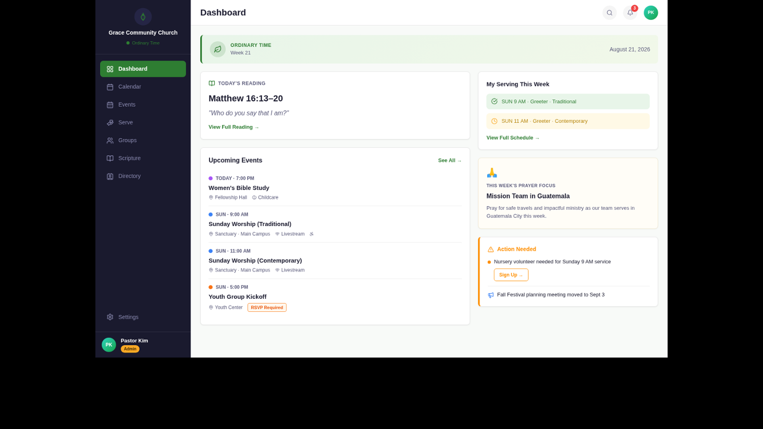
Figure 1. Dashboard / Home — Web UI Mockup (Ordinary Time · August 2026)
┌──────────┬─────────────────────────────────────────────────────────────────┐
│ │ │
│ NAV │ +-- LITURGICAL SEASON BANNER --------------------------------+ │
│ │ | ● Ordinary Time · Week 21 · Aug 21, 2026 | │
│ Home │ +---------------------------------------------------------------+ │
│ Calendar │ │
│ Groups │ +-- TODAYS SCRIPTURE -------------------------------------------+ │
│ Devotnl │ | [Book] Matthew 16:13-20 - "Who do you say that I am?" | │
│ Voluntr │ +---------------------------------------------------------------+ │
│ Admin │ │
│ │ +-- UPCOMING EVENTS (Next 7 Days) ------------------------------+ │
│ ---------│ | | │
│ CAMPUSES │ | TODAY - Aug 21 | │
│ o Main │ | +----------------------------------------------------------+ | │
│ o North │ | | [Prp] 7:00 PM Women's Bible Study | | │
│ o Online │ | | Fellowship Hall · [Baby] Childcare · 12/20 RSVP| | │
│ │ | +----------------------------------------------------------+ | │
│ ---------│ | | │
│ CATEGORS │ | SUN - Aug 24 | │
│ [X] Worsh│ | +----------------------------------------------------------+ | │
│ [X] Youth│ | | [Blu] 9:00 AM Sunday Worship (Traditional) | | │
│ [X] Outrch│ | | Sanctuary · [TV] Livestream · [WC] Accessible | | │
│ [X] Admin│ | +------ --- --- --- --- --- --- --- --- --- --- --- ---+ | │
│ [X] Socl │ | | [Ora] 5:00 PM Youth Group Kickoff | | │
│ │ | | Youth Center · RSVP Required · [Register ->] | | │
│ │ | +----------------------------------------------------------+ | │
│ │ +---------------------------------------------------------------+ │
│ │ │
│ │ +-- PRAYER FOCUS THIS WEEK ---------------------------------+ │
│ │ | [Pray] "Pray for our mission team in Guatemala" | │
│ │ +-----------------------------------------------------------+ │
│ │ │
│ │ +-- ALERTS -------------------------------------------------+ │
│ │ | [!] Volunteer needed: Nursery - Sunday 9 AM service | │
│ │ | [Ann] Fall Festival planning meeting moved to Sept 3 | │
│ │ +-----------------------------------------------------------+ │
└──────────┴─────────────────────────────────────────────────────────────────┘

6.3 Screen 2: Calendar View (Month)
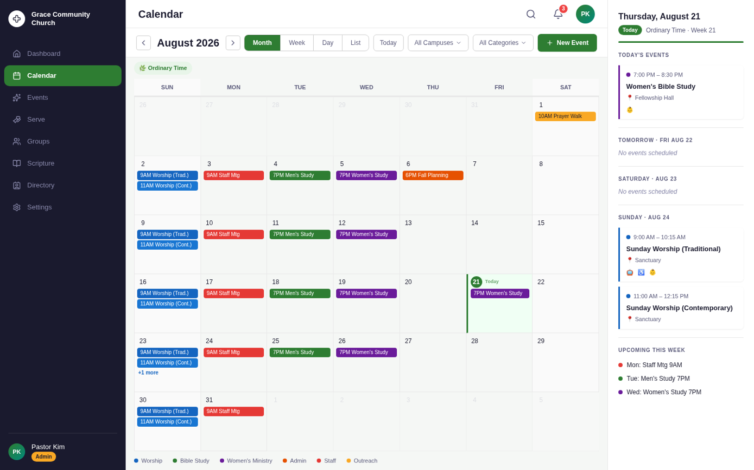
Figure 2. Calendar View (Monthly) — Web UI Mockup (August 2026)
┌──────────┬─────────────────────────────────────────────────────────────────┐
│ │ │
│ NAV │ <- August 2026 -> [Month] [Week] [Day] [List] [+ Event]│
│ │ │
│ │ Filter: [All Campuses v] [All Categories v] [Search... [Q]] │
│ │ │
│ │ +--------+--------+--------+--------+--------+--------+-------+ │
│ │ | SUN | MON | TUE | WED | THU | FRI | SAT | │
│ │ +--------+--------+--------+--------+--------+--------+-------+ │
│ │ | | | | | | | 1 | │
│ │ +--------+--------+--------+--------+--------+--------+-------+ │
│ │ | 2 | 3 | 4 | 5 | 6 | 7 | 8 | │
│ │ | [B]9AM | |[G]7PM |[P]7PM | | | [O]9A | │
│ │ | Worshp | | Mens | Women | | | Youth | │
│ │ +--------+--------+--------+--------+--------+--------+-------+ │
│ │ | 16 | 17 | 18 | 19 | 20 | *21* | 22 | │
│ │ | [B]9AM | |[G]7PM |[P]7PM | | |[Y]ALL | │
│ │ | Worshp | | Mens | Women | | | Retr. | │
│ │ +--------+--------+--------+--------+--------+--------+-------+ │
│ │ | 30 | 31 | | | | | | │
│ │ | [B]9AM | | | | | | | │
│ │ +--------+--------+--------+--------+--------+--------+-------+ │
│ │ │
│ │ LEGEND: [B]=Worship [G]=Mens [P]=Womens [O]=Youth │
│ │ [R]=Admin [Y]=All-Church [Dot]=Outreach │
└──────────┴─────────────────────────────────────────────────────────────────┘

6.4 Screen 3: Event Detail Flyout Panel
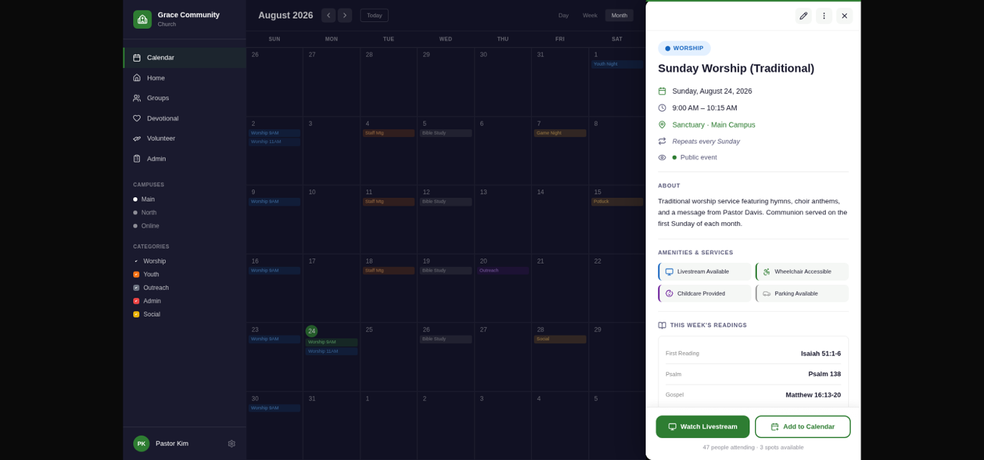
Figure 3. Event Detail Flyout Panel — Web UI Mockup
EVENT DETAIL PANEL (slides in from right, calendar dimmed behind)

┌────────────────┐
│ EVENT DETAIL │
│ │
│ [Blu] WORSHIP │
│ │
│ Sunday Worship │
│ (Traditional) │
│ ───────────── │
│ [Cal] Sun Aug 24│
│ [Clk] 9:00-10:15│
│ [Pin] Sanctuary │
│ Main Campus│
│ [Rec] Weekly │
│ ───────────── │
│ AMENITIES │
│ [TV] Livestream │
│ [WC] Accessible │
│ [Baby]Childcare │
│ [P] Parking │
│ ───────────── │
│ SCRIPTURE │
│ [Book]Matt 16:13│
│ [Book]Psalm 138 │
│ ───────────── │
│ VOLUNTEERS │
│ Greeter: J.Lee │
│ Sound: M.Park │
│ Nursery: OPEN[!]│
│ ───────────── │
│ CONTACT │
│ Pastor Kim │
│ ───────────── │
│ [Watch Live] │
│ [Add to Cal] │
│ [Edit Event] │
└────────────────┘

6.5 Screen 4: Volunteer Schedule View
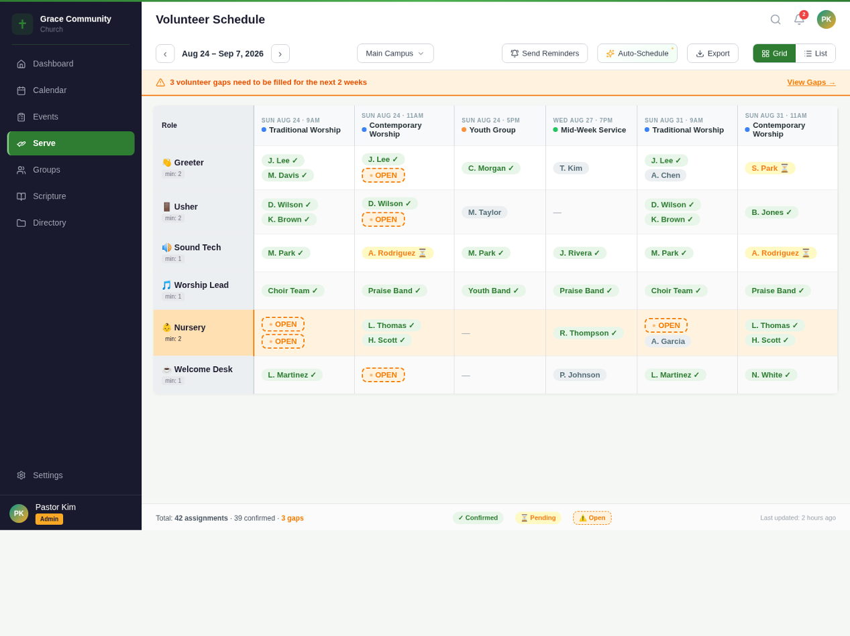
Figure 4. Volunteer Schedule View — Web UI Mockup
┌───────────────────────────────────────────────────────────────────────────┐
│ VOLUNTEER SCHEDULE Week of Aug 24, 2026 [+ Assign] │
│ │
│ +----------+--------------+--------------+-----------------+ │
│ | ROLE | SUN 9:00 AM | SUN 11:00 AM | WED 7:00 PM | │
│ +----------+--------------+--------------+-----------------+ │
│ | Greeter | J. Lee [V] | S. Kim [V] | T. Park [V] | │
│ | | R. Adams[V] | M. Chen [?] | | │
│ +----------+--------------+--------------+-----------------+ │
│ | Usher | B. Wilson[V] | D. Brown[V] | -- | │
│ | | K. Davis[V] | [!] OPEN | | │
│ +----------+--------------+--------------+-----------------+ │
│ | Sound | M. Park [V] | J. Rivera[V] | M. Park [V] | │
│ +----------+--------------+--------------+-----------------+ │
│ | Nursery | [!] OPEN | L. Thomas[V] | -- | │
│ | | A. Garcia[V] | H. Scott [V] | | │
│ +----------+--------------+--------------+-----------------+ │
│ | Music | Choir [V] | Band [V] | -- | │
│ +----------+--------------+--------------+-----------------+ │
│ │
│ [V] = Confirmed [?] = Pending [!] = Needs Volunteer │
│ │
│ [Send Reminders] [Auto-Schedule] [Export CSV] │
└───────────────────────────────────────────────────────────────────────────┘

6.6 Screen 5: Create / Edit Event Modal
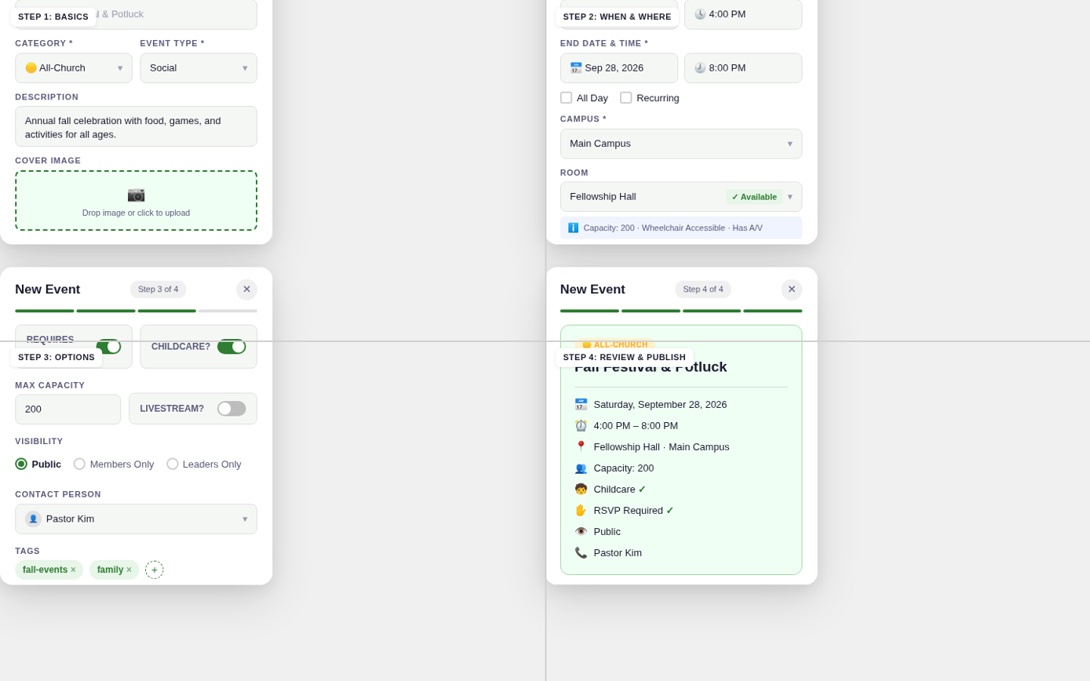
Figure 5. Create / Edit Event Modal (4-Step Wizard) — Web UI Mockup
┌───────────────────────────────────────────────────────────┐
│ CREATE NEW EVENT [X] │
├───────────────────────────────────────────────────────────┤
│ │
│ Event Title * │
│ +-------------------------------------------------------+ │
│ | Fall Festival & Potluck | │
│ +-------------------------------------------------------+ │
│ │
│ Category * Event Type * │
│ +-----------------+ +-----------------+ │
│ | [Y] All-Church v| | Social v | │
│ +-----------------+ +-----------------+ │
│ │
│ Start Date/Time * End Date/Time * │
│ +---------------------+ +---------------------+ │
│ | Sep 28, 2026 4:00PM| | Sep 28, 2026 8:00PM| │
│ +---------------------+ +---------------------+ │
│ │
│ [ ] All Day Event [ ] Recurring [Set Recurrence...] │
│ │
│ Campus * Room │
│ +-----------------+ +-----------------+ │
│ | Main Campus v | | Fellowship Hall v| │
│ +-----------------+ +-----------------+ │
│ │
│ OPTIONS -------------------------------------------------│
│ [X] Requires RSVP Max Capacity: [200] │
│ [X] Childcare Registration URL: [__________] │
│ [ ] Livestream Livestream URL: [__________] │
│ │
│ Visibility: (*) Public ( ) Members Only ( ) Leaders │
│ │
│ Contact Person: [Pastor Kim v] │
│ │
│ +---------------------------------------------------------+ │
│ | [Cancel] [Save as Draft] [Publish] | │
│ +---------------------------------------------------------+ │
└───────────────────────────────────────────────────────────┘

7. Mobile Experience Design
The mobile application (React Native, iOS & Android) is designed around a thumb-zone-first philosophy, ensuring all primary actions are within natural reach while delivering a liturgically immersive, accessible, and offline-capable experience.

7.1 Design Philosophy
Principle | Rationale
Thumb-zone first | Primary actions within natural thumb reach (bottom 60% of screen)
Liturgical immersion | Season colors and imagery subtly theme the entire app with seasonal gradient morphs
Glanceable | Key information visible without scrolling or tapping from the dashboard
Offline-capable | 24-hour cached schedule viewable without connectivity; writes queue and sync on reconnect
Inclusive | Dynamic Type, VoiceOver/TalkBack, high-contrast mode, RTL layout support (Arabic, Hebrew)
Notification-led | Push notifications drive engagement via deep links to specific in-app screens

7.2 Information Architecture (5-Tab Navigation)
+---------------------------------------------------------------+
| BOTTOM TAB BAR (5 tabs) |
+------+------+------+------+------+ |
| Home | Cal | + | Vol | More | |
| [H] | [Cal]| [+] | [Srv]| [=] | |
+------+------+------+------+------+ +

[H] HOME (Dashboard)
|-- Liturgical Banner (season + week)
|-- Today's Scripture Card
|-- Upcoming Events (scrollable list)
|-- Prayer Focus Card
`-- My Volunteer Assignments

[Cal] CALENDAR
|-- Month View (swipeable, pinch to week)
|-- Week View (horizontal time grid)
|-- Day View (hourly slots)
|-- List View (chronological)
`-- Filters (campus, category, date)

[+] QUICK ADD (FAB bottom sheet)
|-- Create New Event
|-- RSVP to Event
|-- Share Prayer Request
`-- Sign Up to Serve

[Srv] SERVE (Volunteer Hub)
|-- My Schedule (confirm/decline cards)
|-- Available Openings (gap board)
|-- Swap Requests
`-- Volunteer History + Stats

[=] MORE
|-- My Groups
|-- Member Directory
|-- Notifications Center
|-- Settings & Preferences
`-- About / Help

7.3 Mobile Screen Wireframes

7.3.1 Home / Dashboard
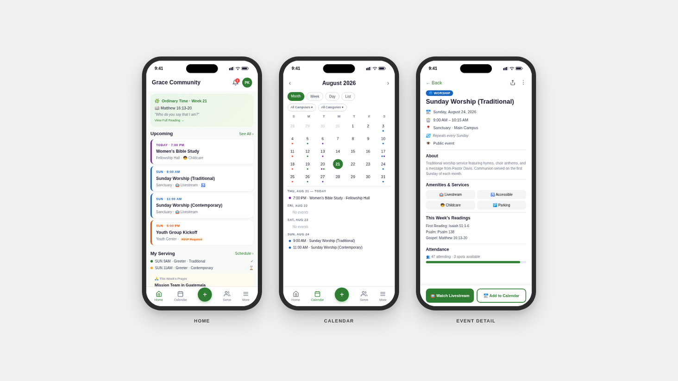
Figure 6. Mobile Core Screens — Home, Calendar, Event Detail (iOS)
+----------------------------------+
| Grace Community [Bell2] [Usr]| <- Header
+----------------------------------+
| +------------------------------+ |
| | [Grn] ORDINARY TIME Wk 21 | | <- Liturgical banner
| | [Book] Matthew 16:13-20 | |
| +------------------------------+ |
| |
| UPCOMING ---------------See All > |
| +------------------------------+ |
| | [Prp] TODAY 7:00 PM | | <- Event card
| | Women's Bible Study | |
| | Fellowship Hall . [Baby] . 12/20| |
| | [RSVP] | |
| +------------------------------+ |
| +------------------------------+ |
| | [Blu] SUN 9:00 AM | |
| | Sunday Worship (Traditional) | |
| | Sanctuary . [TV] . [WC] | |
| +------------------------------+ |
| |
| MY SERVING ----------Schedule > |
| +------------------------------+ |
| | [Bolt] SUN 9AM . Greeter | | <- Assignment chip
| | [Bolt] SUN 11AM . Greeter | |
| +------------------------------+ |
| |
| THIS WEEKS PRAYER |
| +------------------------------+ |
| | [Pray] Pray for Guatemala | |
| +------------------------------+ |
+----------------------------------+
| [H] [Cal] [+] [Srv] [=] | <- Bottom nav
+----------------------------------+

7.3.2 Calendar Month View
+----------------------------------+
| <- August 2026 -> [Q] [Settings]|
+----------------------------------+
| Campus: [Main v] [All Cats v] | <- Filter chips
+----------------------------------+
| SU MO TU WE TH FR SA |
| -- -- -- -- -- -- -- |
| 1 |
| 2 3 4 5 6 7 8 |
| [B] [G] [P] [O] |
| 9 10 11 12 13 14 15 |
| [B] [G] [P] [R] |
| 16 17 18 19 20 *21 22 |
| [B] [G] [P] [Y] |
| 23 24 25 26 27 28 29 |
| [B] [G] [P] |
| 30 31 |
| [B] |
+----------------------------------+
| AUG 21 (TODAY) |
| +------------------------------+ |
| | No events today | |
| | Tomorrow: [P] 7PM Womens | |
| +------------------------------+ |
+----------------------------------+
| [H] [Cal] [+] [Srv] [=] |
+----------------------------------+

Interactions: Swipe L/R = next/prev month
Tap date = bottom sheet with day events
Pinch = toggle month <-> week view
Long-press = quick-add event

7.3.3 Calendar Week View
+----------------------------------+
| <- Aug 17-23, 2026 -> |
+----------------------------------+
| SU 17 | MO 18 | TU 19 | WE 20 | <- Swipeable columns
+-------+-------+-------+--------+
| 9AM | | | |
| +[B]+ | | 7PM | 7PM |
| |Wrsh| | | +[G]+ | +[P]+ |
| +----+ | | |Men| | |Wom| |
| | | +---+ | +---+ |
| 11AM | | | |
| +[B]+ | | | |
| |Cont| | | | |
| +----+ | | | |
| 5PM | | | |
| +[O]+ | | | |
| |Yth | | | | |
| +----+ | | | |
+----------------------------------+
| [H] [Cal] [+] [Srv] [=] |
+----------------------------------+

7.3.4 Event Detail (Full Screen)
+----------------------------------+
| [<- Back] [... Menu]|
+----------------------------------+
| +----------------------------+ |
| | [Blu] WORSHIP SERVICE | | <- Category badge
| +----------------------------+ |
| |
| Sunday Worship (Traditional) |
| ───────────────────────────── |
| [Cal] Sunday, August 24, 2026 |
| [Clk] 9:00 AM - 10:15 AM |
| [Pin] Sanctuary . Main Campus |
| [Rec] Repeats weekly |
| ───────────────────────────── |
| Traditional worship with hymns, |
| choir anthems, and sermon. |
| ───────────────────────────── |
| AMENITIES |
| [TV] Livestream [WC] Accessible |
| [Baby] Childcare [P] Parking |
| ───────────────────────────── |
| THIS WEEKS READINGS |
| [Book] Isaiah 51:1-6 |
| [Book] Psalm 138 |
| [Book] Matthew 16:13-20 |
| ───────────────────────────── |
| SERVING THIS SUNDAY |
| Greeter: J. Lee [V] |
| Sound: M. Park [V] |
| Nursery: [!] OPEN |
| [Volunteer for Nursery ->] |
+----------------------------------+
| [Watch Live] [Add to Cal] | <- Sticky actions
+----------------------------------+

7.3.5 Serve / Volunteer Hub
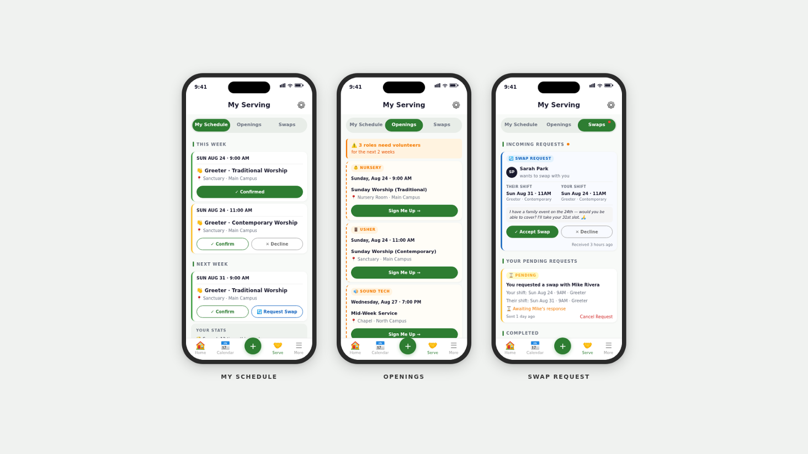
Figure 7. Mobile Serve Screens — My Schedule, Available Openings, Swap Requests (iOS)
+----------------------------------+
| MY SERVING [Cfg]|
+----------------------------------+
| [My Schedule] [Openings] [Swap] | <- Segment control
+----------------------------------+
| THIS WEEK ───────────────── |
| +------------------------------+ |
| | SUN AUG 24 . 9:00 AM | |
| | Greeter . Traditional | |
| | Sanctuary . Main Campus | |
| | [Confirm] [Decline] | |
| +------------------------------+ |
| +------------------------------+ |
| | SUN AUG 24 . 11:00 AM | |
| | Greeter . Contemporary | |
| | [Confirmed V] | |
| +------------------------------+ |
| NEXT WEEK ───────────────── |
| +------------------------------+ |
| | SUN AUG 31 . 9:00 AM | |
| | Greeter . Traditional | |
| | [Confirm] [Swap] | |
| +------------------------------+ |
| ─── STATS ────────────────── |
| Served: 12 times this quarter |
| Streak: 4 weeks [Fire] |
+----------------------------------+
| [H] [Cal] [+] [Srv] [=] |
+----------------------------------+

7.3.6 Available Openings
+----------------------------------+
| [My Schedule] [Openings] [Swap] |
+----------------------------------+
| [!] 3 ROLES NEED VOLUNTEERS |
| +------------------------------+ |
| | [Baby] NURSERY | |
| | Sun Aug 24 . 9:00 AM | |
| | Traditional . Main Campus | |
| | [Sign Me Up ->] | |
| +------------------------------+ |
| +------------------------------+ |
| | [Door] USHER | |
| | Sun Aug 24 . 11:00 AM | |
| | Contemporary . Main Campus | |
| | [Sign Me Up ->] | |
| +------------------------------+ |
| +------------------------------+ |
| | [Sound] SOUND TECH | |
| | Wed Aug 27 . 7:00 PM | |
| | Mid-Week . North Campus | |
| | [Sign Me Up ->] | |
| +------------------------------+ |
+----------------------------------+

7.3.7 Quick Add Bottom Sheet
+----------------------------------+
| (Dimmed background) |
+----------------------------------+
| ─── (drag handle) ─── |
| |
| WHAT WOULD YOU LIKE TO DO? |
| |
| +------------------------------+ |
| | [Cal] Create Event | |
| | Add a new event | |
| +------------------------------+ |
| +------------------------------+ |
| | [Hand] RSVP to Event | |
| | Register for an event | |
| +------------------------------+ |
| +------------------------------+ |
| | [Pray] Share Prayer Request | |
| | Submit a request | |
| +------------------------------+ |
| +------------------------------+ |
| | [Srv] Sign Up to Serve | |
| | Pick an opening | |
| +------------------------------+ |
+----------------------------------+

7.3.8 Event Creation (4-Step Wizard)
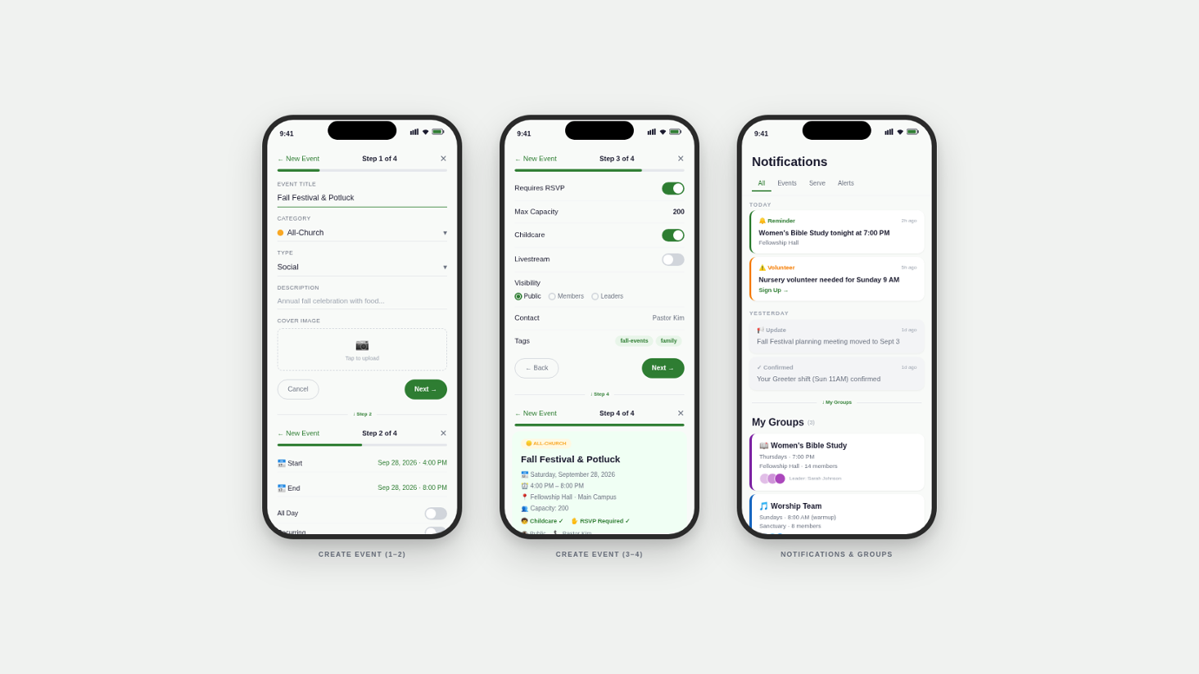
Figure 8. Mobile Event Creation Wizard & Notifications / Groups (iOS)
STEP 1/4 - BASICS STEP 2/4 - WHEN & WHERE
+-----------------------------+ +-----------------------------+
| [X Cancel] [Next ->] | | [<- Back] [Next ->] |
+-----------------------------+ +-----------------------------+
| Event Title * | | Start * |
| +-----------------------+ | | +---------------------+ |
| | Fall Festival | | | | Sep 28 . 4:00 PM | |
| +-----------------------+ | | +---------------------+ |
| | | End * |
| Category * | | +---------------------+ |
| +-----------------------+ | | | Sep 28 . 8:00 PM | |
| | [Y] All-Church v | | | +---------------------+ |
| +-----------------------+ | | [ ] All Day [ ] Recurring |
| Event Type * | | Campus * |
| +-----------------------+ | | +-----------------------+ |
| | Social v | | | | Main Campus v | |
| +-----------------------+ | | +-----------------------+ |
| Description | | Room |
| +-----------------------+ | | +-----------------------+ |
| | Annual fall event | | | | Fellowship Hall v | |
| +-----------------------+ | | +-----------------------+ |
| (o) (o) (o) (o) progress | | Capacity: 200 |
+-----------------------------+ +-----------------------------+

STEP 3/4 - OPTIONS STEP 4/4 - REVIEW & PUBLISH
+-----------------------------+ +-----------------------------+
| Requires RSVP? [ON green] | | [Y] ALL-CHURCH |
| Max Capacity: [200] | | Fall Festival & Potluck |
| Childcare? [ON green] | | Sep 28, 2026 4-8PM |
| Livestream? [-- OFF --] | | Fellowship Hall . Main |
| Visibility: | | [Baby] RSVP [V] Public[V] |
| (*) Public | | Pastor Kim |
| ( ) Members Only | | |
| ( ) Leaders Only | | [Save Draft] [Publish V] |
+-----------------------------+ +-----------------------------+

7.3.9 Notifications Center
+----------------------------------+
| [<- Back] NOTIFICATIONS |
+----------------------------------+
| [All] [Reminders] [Alerts] [Vol] | <- Filter chips
+----------------------------------+
| TODAY ──────────────────── |
| +------------------------------+ |
| | [Bell] Reminder . 2h ago | | <- Unread (bold)
| | Womens Bible Study tonight | |
| | 7:00 PM . Fellowship Hall | |
| +------------------------------+ |
| +------------------------------+ |
| | [!] Volunteer . 5h ago | |
| | Nursery needed Sun 9 AM | |
| | [Sign Up ->] | |
| +------------------------------+ |
| YESTERDAY ───────────────── |
| +------------------------------+ |
| | [Ann] Update . 1d ago | | <- Read (dimmed)
| | Fall Festival moved Sept 3 | |
| +------------------------------+ |
| +------------------------------+ |
| | [V] Confirmed . 1d ago | |
| | Greeter Sun 11AM confirmed | |
| +------------------------------+ |
+----------------------------------+

7.3.10 My Groups
+----------------------------------+
| [<- Back] MY GROUPS |
+----------------------------------+
| +------------------------------+ |
| | [Book] Womens Bible Study | |
| | Thursdays . 7:00 PM | |
| | Fellowship Hall . 14 mmbrs | |
| | Leader: Sarah Johnson | |
| | [View ->] | |
| +------------------------------+ |
| +------------------------------+ |
| | [Music] Worship Team | |
| | Sundays . 8:00 AM (warmup) | |
| | Sanctuary . 8 members | |
| | Leader: Mike Rivera | |
| | [View ->] | |
| +------------------------------+ |
| +------------------------------+ |
| | [Globe] Missions Committee | |
| | 1st Monday . 6:30 PM | |
| | Room 204 . 6 members | |
| | Leader: Pastor Davis | |
| | [View ->] | |
| +------------------------------+ |
| + - - - - - - - - - - - - - -+ |
| Browse All Groups -> |
| + - - - - - - - - - - - - - -+ |
+----------------------------------+

7.4 Gesture & Interaction Patterns
Gesture | Context | Action
Swipe left/right | Calendar month | Navigate to next/previous month
Swipe left on card | Event list | Quick RSVP or dismiss event
Swipe right on assignment | Volunteer list | Confirm shift in one gesture
Pull down | Any list | Refresh data from server
Long press on date | Calendar | Quick-add event on that date
Pinch in/out | Calendar | Toggle between month and week view
Tap + hold event | Calendar | Drag to reschedule (leaders and above)
3D Touch / Haptic Peek | Event card | Peek at event detail without full navigation

7.5 Push Notification Strategy
Notification Type | Timing | Deep Link Target
Event reminder | 1 hour before (configurable) | roca://event/{id} → Event Detail
Volunteer reminder | 24h before assigned shift | roca://serve/schedule → My Schedule
Volunteer gap alert | When opening is posted | roca://serve/openings → Openings
Event cancellation | Immediately on cancel | roca://event/{id} → Detail (cancelled status)
RSVP confirmation | On successful registration | roca://event/{id} → Event Detail
Swap request | When someone requests swap | roca://serve/swaps → Swap Requests
New event (subscribed) | On publish | roca://event/{id} → Event Detail
Weekly digest | Sunday 7 AM | roca://home → Dashboard
Scripture of the day | 6 AM daily (opt-in) | roca://home → Scripture Card

7.6 Offline Mode Behavior
Feature | Offline Behavior
Calendar view | Shows cached events (synced within last 24h); visual offline banner displayed
Event details | Cached details available; read-only with stale indicator
RSVP / Registration | Queued locally in device DB; syncs when connectivity restored
Volunteer confirm/decline | Queued locally; syncs when online; server-side validation on sync
Event creation | Saved as local draft; automatically publishes when connectivity returns
Scripture readings | Current week cached for offline devotional reading
Visual indicator | Subtle top banner: "Offline · Changes will sync when connected"

7.7 Liturgical Season Theming
Season | Primary Color | Accent | Background Tint
Advent | Deep Purple | Gold | #F3E8FF
Christmas | White / Gold | Red | #FFFBEB
Epiphany | Green | Gold | #F0FFF4
Lent | Purple | Grey | #FAF5FF
Holy Week | Red / Black | Gold | #FFF5F5
Easter | White / Gold | Green | #FFFFF0
Pentecost | Red | Orange | #FFF5F5
Ordinary Time | Green | Brown | #F0FFF4

7.8 Accessibility Features
Feature | Implementation
Dynamic Type | All text respects iOS/Android font scaling settings
VoiceOver / TalkBack | Full semantic labels on all interactive elements and state changes
Color Contrast | WCAG 2.1 AA minimum: 4.5:1 for text, 3:1 for UI components
Color-Blind Safe | Category dots include unique shapes as secondary indicator beyond color
Reduce Motion | Respects system setting; disables parallax, particle effects, and non-essential animations
High Contrast Mode | Bolder borders, no translucency, increased text weight
RTL Support | Full mirror layout for Arabic and Hebrew locales
Haptic Feedback | Confirmation taps on confirm/decline actions via iOS Taptic Engine
Focus Management | Logical tab order in all forms; focus trapping in modals

8. User Flows

8.1 New Member Onboarding Flow
START --> Download App --> Select Org (search/invite code) --> Create Account
|
(submit form)
|
+-------------v-----------+
+------------+ +-------------+ | PENDING APPROVAL SCREEN |
| DASHBOARD |<---| Admin/Auto |<----- | "We will notify you..." |
| (Active) | | Approves | +-------------------------+
+-----+------+ +-------------+
|
v
+------------------------------------------------------------------+
| ONBOARDING WIZARD (first-time, skippable) |
| Step 1: Select Campus -> Step 2: Choose Categories -> |
| Step 3: Join Groups -> Step 4: Set Notification Prefs -> |
| Step 5: Volunteer Interests (optional) -> DONE |
+------------------------------------------------------------------+

8.2 Event Discovery & RSVP Flow
ENTRY POINTS:
- Dashboard upcoming list - Push notification deep link
- Calendar tap on date - Search results
- Group event listing - Shared external link
|
v
+-----------------------------+
| EVENT DETAIL SCREEN |
| (title, date, amenities, |
| scripture, volunteers) |
+----+--------+----------+----+
| | |
RSVP Add to Cal Watch Live
|
v
+-------------------+
| Capacity Available|
+---+----------+----+
| |
YES NO
| |
v v
+--------+ +------------------+
|Party Sz| | Join Waitlist? |
|+ Notes | +---+----------+---+
+---+----+ YES NO
| | |
v v v
Confirmed Waitlisted End
+ Email + Position#
+ .ics

8.3 Event Creation Flow (Leader / Admin / Pastor)
ENTRY: FAB(+) / Calendar long-press / Admin menu
|
v
+--------+-------+------------+----------+
| STEP 1 |STEP 2 | STEP 3 | STEP 4 |
| Basics |When/ | Options | Review |
| |Where | | |
|.Title |.Start |.RSVP |.Preview |
|.Categ |.End |.Capacity |.Confirm |
|.Type |.Recur?|.Childcare | |
|.Descr |.Campus|.Livestream |[Publish] |
| |.Room |.Visibility |[Draft] |
+--------+--+----+------------+----+-----+
|
CONFLICT CHECK (on Step 2)
|
+------+------+
CLEAR CONFLICT
| |
Continue Show conflicts +
suggest alt rooms
|
+----------+----------+
PUBLISHED DRAFT
Visible + notifies Not visible
subscribers Resumable

8.4 Volunteer Assignment & Confirmation Flow
SCHEDULING PATHS:
A) Admin manual assign B) Auto-scheduler C) Self sign-up
| | |
Select: event Set date range, Browse Openings,
role, volunteer strategy, roles tap "Sign Me Up"
| | |
| Admin reviews draft |
+---------------+ +-----------+-------+
|
ASSIGNMENT CREATED (status: ASSIGNED)
Push notification sent to volunteer
|
+-------------+------------------+
| | |
CONFIRM DECLINE REQUEST SWAP
| | |
status:CONFIRMED GAP CREATED SWAP_PENDING
Reminder 24h Alert admin Notify target
before event Post to board |
Notify eligible +----+----+
volunteers ACCEPTED REJECTED
Both notif Original

8.5 Event Cancellation & Notification Flow
Admin/Pastor: event -> menu -> Cancel
|
v
+--------------------+
| IS EVENT RECURRING?|
+---+------+---------+
| |
ONE-TIME RECURRING
| |
| Select scope:
| ( ) This instance only
| ( ) This and future
| ( ) All instances
+------+
|
+----------v--------------+
| CANCELLATION FORM |
| Reason: [__________] |
| [X] Notify registered |
| [X] Notify volunteers |
| [ ] Public announcement |
| [Cancel Event] [Back] |
+-----------+-------------+
|
SYSTEM ACTIONS:
1. Event status -> CANCELLED
2. Volunteer assignments -> RELEASED
3. Push notifications -> all registered
4. Email -> all registered + volunteers
5. Calendar .ics update -> CANCELLED
6. Dashboard alert posted
7. Waitlisted users notified
8. Webhook fired: event.cancelled

8.6 Scripture & Lectionary Management Flow
ENTRY PATHS: A) Manual per event B) Bulk import C) Edit existing
| | |
Select event Choose lectionary Navigate to
or date (RCL/Cath/Luth), existing via
| year (A/B/C), event detail
Add reading: date range |
.type (gospel/psalm) | Edit reference
.reference ("John 3:16") "Preview: 208 or text
.text (optional) readings to add"
| [Confirm/Cancel]
+---------------+---------------+
|
READINGS SAVED
. Visible on event detail
. Dashboard today card
. Widget display
. Daily push (opt-in)

8.7 Recurring Event Management Flow
Creating recurring:
Pattern: [Weekly v] On: [X Sun O Mon ...]
Until: ( ) Never ( ) Date ( ) After N occurrences
-> RRULE generated: FREQ=WEEKLY;BYDAY=SU;UNTIL=20261231

Editing / Cancelling a recurring event instance:
+------------------+ +-----------------+ +-----------------+
| THIS INSTANCE | | THIS & FUTURE | | ALL INSTANCES |
| ONLY | | | | |
| Creates exception| | New series from | | Updates master |
| Original series | | this date with | | + all past & |
| unchanged | | new properties; | | future instances|
| | | original ends | | |
+------------------+ +-----------------+ +-----------------+

Exception Storage (recurrence_exceptions table):
. exception_id (UUID)
. event_id (parent series)
. original_date (DATE)
. exception_type: modified | cancelled | rescheduled
. override_event_id (points to modified copy)

8.8 Push Notification Engagement Flow
TRIGGER EVENTS:
Event in 1 hour, Volunteer assigned, Event cancelled,
Volunteer gap, RSVP confirmed, Swap request
|
v
+---------------------------+
| Notification Service: |
| . User preferences check |
| . Quiet hours? |
| . Category subscribed? |
| . Device token valid? |
| . Badge count update |
+---+----------+------------+
| | |
PUSH IN-APP EMAIL
(APNs/FCM) BADGE (digest or
. Title updated instant)
. Body
. Deep link
|
USER TAPS PUSH
|
DEEP LINK ROUTING:
roca://event/{id} -> Event Detail
roca://serve/schedule -> My Schedule
roca://serve/openings -> Openings
roca://notifications -> Notification List
roca://groups/{id} -> Group Page

9. State Diagrams

9.1 Event Lifecycle State Machine
[DRAFT] --[publish]--> [ACTIVE] --[cancel]--> [CANCELLED]
| \ (reason stored,
[postpone] [time passes] notifications sent)
| |
[POSTPONED] [IN_PROGRESS]
| (happening now)
[reschedule] |
| [end time reached]
[ACTIVE] |
[COMPLETED]
(archived, attendance recorded)

TRANSITION TABLE:
From | To | Trigger | Who
------------|-------------|-------------------|------------------
DRAFT | ACTIVE | Publish action | Creator+
DRAFT | (deleted) | Discard | Creator+
ACTIVE | CANCELLED | Cancel action | Admin/Pastor
ACTIVE | POSTPONED | Postpone action | Admin/Pastor
ACTIVE | IN_PROGRESS | Start time hit | System (cron)
POSTPONED | ACTIVE | Reschedule | Admin/Pastor
POSTPONED | CANCELLED | Cancel action | Admin/Pastor
IN_PROGRESS | COMPLETED | End time hit | System (cron)

9.2 Registration / RSVP State Machine
[REGISTERED] <---------(promoted from waitlist)
|
+---------------+------------------+
| |
[cancel] [event starts]
| |
[CANCELLED] [ATTENDED]
(spot freed; (checked in at event)
waitlist promoted)
[WAITLISTED] --(spot opens)--> [REGISTERED]
|
[cancel]
|
[CANCELLED (from wait)]

TRANSITION TABLE:
From | To | Trigger | Side Effect
------------|-------------|---------------------|-------------------
(new) | REGISTERED | RSVP + capacity OK | Confirmation email
(new) | WAITLISTED | RSVP + at capacity | Waitlist position #
REGISTERED | CANCELLED | User/admin cancels | Promote waitlist #1
WAITLISTED | REGISTERED | Spot opens | Promotion notification
REGISTERED | ATTENDED | Check-in scan | Attendance logged
REGISTERED | NO_SHOW | Event ends, no check| Analytics recorded

9.3 Volunteer Assignment State Machine
[ASSIGNED] --[confirm]--> [CONFIRMED] --[event starts]--> [SERVED]
| (stats updated,
|--[decline]--> [DECLINED] streak tracked)
| (gap created,
| alert admin)
|
`--[request_swap]--> [SWAP_PENDING] --[accepted]--> [SWAPPED]
| (old released,
| new assigned)
`--[rejected]--> [CONFIRMED]
| (remains original)
`--[48h timeout]--> [EXPIRED]
(notify both + admin)

CONFIRMED can also transition:
CONFIRMED --[late cancel]--> DECLINED --[gap created]--> notify eligible vols
ASSIGNED --[event cancelled]--> RELEASED (push to volunteer)

9.4 Member Account State Machine
REGISTRATION ---> [PENDING APPROVAL]
|
+-----------+----------+
APPROVE REJECT
| |
[ACTIVE] [REJECTED]
| (can reapply)
+----------+----------+
| | |
[deactivate][role_change][suspend]
| | |
[INACTIVE][ACTIVE (new role)][SUSPENDED]
(data retained; (permissions updated) (temp no login;
can reactivate) review period)
|
[reinstate]
|
[ACTIVE]

ROLE HIERARCHY (each inherits lower roles):
guest -> member -> volunteer -> leader -> admin -> pastor -> super_admin

9.5 Notification Delivery State Machine
[CREATED] --[immediate]--> [QUEUED] --[processing]--> [DELIVERING]
| |
`--[scheduled]--> [SCHEDULED] --[send time]--> [QUEUED] |
| |
[cancelled] +-------------+----------+
| | |
[DELIVERED] [PARTIAL] [FAILED]
(all channels) (some fail) (all fail)
|
[retry up to 3x]
|
[PERMANENTLY FAILED]
(logged, admin alerted)

USER INTERACTION STATES:
UNREAD --[open]--> READ
| |
`--[dismiss]--> DISMISSED READ can trigger ACTIONED (CTA tapped)

9.6 Liturgical Season Annual Cycle
+------------------------------------------------------------------+
| |
| [ADVENT] --> [CHRISTMAS] --> [ORDINARY I] --> [LENT] |
| 4 wks 12 days ~4-9 wks 40 days |
| Purple White/Gold Green Purple |
| | |
| [ORDINARY II] <-- [PENTECOST] <-- [EASTER] <-- [HOLY WEEK] |
| ~25-29 wks 1 day 50 days Red |
| Green Red White/Gold |
| | |
| `--[First Sunday of Advent]---> (cycle repeats) |
+------------------------------------------------------------------+

TRANSITION COMPUTATION (date-driven, annually):
. Advent: 4th Sunday before Dec 25
. Christmas: December 25
. Ordinary I: Day after Epiphany (Jan 6)
. Lent: Ash Wednesday (46 days before Easter)
. Holy Week: Palm Sunday (7 days before Easter)
. Easter: First Sunday after Paschal Full Moon
. Pentecost: 50 days after Easter
. Ordinary II: Day after Pentecost

SYSTEM BEHAVIOR ON TRANSITION:
1. Update app theme colors (gradient morph over 2 days)
2. Update dashboard liturgical banner
3. Load new season default scripture cycle (A/B/C rotation)
4. Update widget displays
5. Fire webhook: season.changed

9.7 Auto-Scheduler Workflow States
[CONFIGURED] --[run]--> [PROCESSING]
(date range, (eval availability,
roles, check history,
strategy) balance fairness,
avoid conflicts)
|
+------------------+-------------------+
| | |
[DRAFT COMPLETE] [PARTIAL] [FAILED]
(all slots filled) (gaps remain) (not enough volunteers,
| | constraint conflict)
+------------------+
|
[ADMIN REVIEW]
(view grid, swap people,
fill gaps manually)
|
+---------------+----------+
| | |
[APPROVE [MODIFY [REJECT
& SEND] & RESEND] & RERUN]
| | |
+---------------+ back to [CONFIGURED]
|
[PUBLISHED]
(assignments created,
volunteers notified,
gaps posted to board)

10. Error Handling & Edge Cases

10.1 Conflict Resolution Matrix
Conflict Scenario | Detection Point | Resolution Strategy
Double-booked room | Event creation Step 2 | Show all alternative open rooms for the time slot; suggest with capacity
Volunteer assigned to overlapping event | Assignment creation | Show existing shift; offer to resolve via swap or decline original
Over-capacity RSVP | Registration submit | Auto-waitlist with position number; notify on promotion
Past-date event creation | Event creation Step 2 | Block creation with inline error: "Start date is in the past"
Concurrent edit (two admins editing same event) | Save action (optimistic lock) | "Event updated since you opened. Merge or overwrite?" with diff view
Offline action conflicts with server state on sync | Sync on reconnect | Queue FIFO; apply; show "Could not save — updated remotely" if stale
Expired swap request (48h timeout) | System scheduled job | Auto-expire; notify both parties; revert to original assignment
All volunteers decline for a role | Post-decline gap detection | Escalate: push to all eligible volunteers; email admin with urgency flag

10.2 Offline Sync State Machine
[ONLINE]
(real-time, all actions immediate)
|
[connectivity lost]
|
[OFFLINE]
(banner shown, reads from cache, writes queued)
|
[user performs action]
|
[ACTION QUEUED]
(stored in local DB, timestamped, retry_count=0)
|
[connectivity restored]
|
[SYNCING]
(process queue FIFO, conflict detection per action)
|
+----+----------+----------+
| | |
SUCCESS CONFLICT FAILED
(applied; (show user: (retry 3x;
queue cleared) merge or then "could
overwrite?) not save")
|
[ONLINE]

10.3 Session & Authentication Lifecycle
APP LAUNCH:
Check stored refresh token -> Valid? -> Silent refresh -> DASHBOARD
|
NO
|
LOGIN SCREEN -> Biometric available?
| |
YES NO
| |
Face/Touch ID Email + Password
| |
FAIL |
| |
Fallback to Email + Password
|
TOKEN PAIR RECEIVED:
. Access token (15 min TTL)
. Refresh token (7 day TTL)
. Stored in Secure Enclave (iOS) / Keystore (Android)

DURING SESSION:
API Call -> Access token valid? -> YES -> Proceed
|
NO (401)
|
Refresh token -> New access token -> Retry original call
|
FAIL (refresh expired)
|
Force logout -> LOGIN SCREEN
"Session expired. Please sign in again."

11. Non-Functional Requirements

11.1 Performance
Metric | Target | Measurement
Dashboard load (web) | < 1.5 seconds | p95 LCP via Core Web Vitals
Calendar render (month) | < 800ms | Including event dot rendering
Event detail load | < 500ms | With registrations and volunteers
API response (p95) | < 300ms | Excluding external service calls
Mobile cold start | < 2 seconds | iOS and Android, cold launch to dashboard
Push notification delivery | < 5 seconds from trigger | APNs/FCM SLA dependent
Calendar export (iCal) | < 2 seconds | For up to 12 months of events

11.2 Security
- TLS 1.3 for all data in transit — no HTTP plaintext connections allowed
- AES-256 encryption at rest for database (RDS) and file storage (S3)
- JWT access tokens with 15-minute TTL; refresh tokens with 7-day TTL
- Bcrypt password hashing with cost factor 12 minimum
- OWASP Top 10 mitigation including XSS prevention, SQL injection prevention (parameterized queries), CSRF protection
- Input sanitization and validation on all API endpoints
- CORS allowlist — only approved origins accepted
- Org-level data isolation enforced at both application and database query layer
- Audit logging for all admin and pastor actions on member data

11.3 Availability & Reliability
Requirement | Specification
Uptime SLA | 99.9% (allows ~8.7 hours downtime/year, excluding planned maintenance)
Database | Multi-AZ RDS with automatic failover; < 60s failover time
API scaling | Auto-scaling ECS instances; health checks every 30s
Circuit breaker | External service calls wrapped in circuit breaker pattern (5 failures = open)
Backups | Daily full backup; hourly incremental; 30-day retention
Recovery Point Objective | RPO < 1 hour
Recovery Time Objective | RTO < 4 hours

11.4 Accessibility
Standard / Requirement | Implementation
WCAG 2.1 Level AA (Web) | Semantic HTML5, ARIA roles/labels, keyboard navigation, focus management
VoiceOver (iOS) | Full semantic labels on interactive elements; state announcements
TalkBack (Android) | Content descriptions on all touchable elements
Dynamic Type | All text scales with system font size preference (iOS & Android)
Minimum touch target | 44x44 pt minimum on all interactive controls (Apple HIG compliant)
Color independence | Category indicators use shape + color (not color alone)
Reduce Motion | System setting respected; animations replaced with cross-fades
RTL layout | Full mirror layout for Arabic and Hebrew; tested with RTL locales

11.5 Internationalization
- UTF-8 encoding throughout all layers
- ICU message format for localized strings
- Timezone-aware: organization-level default + user-level override
- All timestamps stored in UTC; displayed in local timezone
- Date and time formatting uses locale-aware libraries (Intl)
- RTL CSS and layout support for Arabic and Hebrew
- Future v3.x: multi-language content for sermons, readings, and notifications
Data Category | Generation Method | Contents | PII Handling
Organizations | Seed script (SQL) | 2 orgs: Grace Community (Protestant) + St. Francis Parish (Catholic) | Synthetic — no real org data
Campuses & Rooms | Seed script (SQL) | 3 campuses per org; 8 rooms per campus; varied capacities and AV configs | Synthetic
Members | Factory function (Faker.js) | 150 members per org; all 7 roles represented; active and inactive states | All names/emails synthetic
Events | Seed script + RRULE generator | 90 days of events; all types; recurring and one-time; all visibility levels | Synthetic titles and descriptions
Registrations | Seed script | Events at 25%, 75%, 100%, and 110% (waitlisted) capacity | Synthetic guest names/emails
Volunteer Assignments | Seed script | All role types; assigned/confirmed/declined/swapped statuses; gaps present | Synthetic member references
Scripture Readings | Lectionary import script | Full RCL Year A cycle; 52 weeks; all reading types | Public domain scripture text
Liturgical Seasons | Season generator | 2 full liturgical years; all 8 seasons; correct date ranges | No PII
Notifications | Seed script | Mix of all 9 notification types; read and unread states | Synthetic event references
Production Snapshot (Staging only) | Weekly automated anonymization pipeline | Real schema and volume; all PII replaced | Names: Faker; emails: hashed; phones: masked
Test data is managed through a combination of database seed scripts, factory functions, and anonymized production snapshots. All personally identifiable information (PII) is masked or replaced with synthetic data before use in non-production environments. Seed data covers a canonical multi-tenant scenario: two organizations, three campuses each, representative member rosters, 90 days of events, and volunteer assignments covering all roles.

12.12 Test Data Management
DoD Criterion | Requirement | Verified By
Unit Tests | All new code paths covered; no failing tests; coverage gate met | CI pipeline (Stage 2)
Integration Tests | All affected API endpoints covered; no regression failures | CI pipeline (Stage 4)
E2E Tests | User journey E2E test written and passing for P1/P2 features | CI pipeline (Stages 5-6)
Security Scan | No new high or critical SAST findings introduced | CI pipeline (Stage 3)
Accessibility | axe-core scan shows zero new violations; keyboard navigation verified | CI pipeline (Stage 7)
Code Review | Minimum 2 peer approvals; no unresolved review comments | GitHub PR approval gates
Performance | No regression in API p95 latency for affected endpoints (< 10% degradation) | Nightly k6 baseline comparison
Documentation | API changes reflected in OpenAPI spec; inline code comments updated | PR checklist + human review
Migration Safety | DB schema migrations are backward-compatible; rollback script provided | DBA review + staging deployment
Feature Flag | New features gated behind feature flags for incremental rollout | Code review + deployment checklist
Acceptance Criteria | All Given-When-Then scenarios from the user story verified and passing | QA Engineer sign-off
Release Notes | Change summarized in CHANGELOG.md with version, date, and description | Release manager review
Every user story and feature must satisfy the following Definition of Done (DoD) criteria before being considered complete. QA Engineers are responsible for verifying acceptance criteria prior to story sign-off. Stories that do not meet all criteria are returned to the development queue for remediation. Acceptance criteria are written in Given-When-Then (GWT) format and linked to specific test case IDs.

12.11 Acceptance Criteria & Definition of Done
Environment | Purpose | Data | Access
Local (Developer) | Unit + integration testing during development | Seeded fixture data; developer-controlled | Developer only; Docker Compose
CI (Ephemeral) | Automated test execution on every PR and merge | Fresh seed on each run; torn down after | GitHub Actions runners; no direct access
Staging | Pre-production validation; E2E + performance + security tests | Anonymized production snapshot; refreshed weekly | Engineering team + QA; isolated DNS
Production | Live environment; smoke tests only post-deploy | Real member and event data; fully encrypted | Restricted; deploy via CI pipeline only
ROCA maintains four distinct environments, each serving a specific phase of the testing lifecycle. Environment configurations are managed via infrastructure-as-code (Terraform) and environment variables. Production mirrors are taken weekly to refresh staging with anonymized production data. Destructive tests (schema drops, bulk deletes) are confined to the local and CI environments only.

12.10 Test Environments
Pipeline Stage | Trigger | Tests Included | Max Duration
Stage 1: Lint & Type Check | Every push | ESLint, TypeScript tsc, Prettier, flake8 | 3 minutes
Stage 2: Unit Tests | Every push | All unit tests (Jest + Pytest); coverage gates | 8 minutes
Stage 3: Security Scan | Every PR | Semgrep SAST, GitLeaks, Snyk dependency audit | 5 minutes
Stage 4: Integration Tests | Every PR | Full API + DB integration suite against ephemeral DB | 15 minutes
Stage 5: E2E Tests (Web) | Merge to main | Playwright E2E on 3 browsers; all P1 journeys | 20 minutes
Stage 6: E2E Tests (Mobile) | Merge to main | Detox on iOS Simulator + Android Emulator | 25 minutes
Stage 7: Accessibility Scan | Merge to main | axe-core scan across all E2E test pages | 5 minutes
Stage 8: Build & Deploy (Staging) | Merge to main | Docker build, push to ECR, deploy to staging ECS | 10 minutes
Stage 9: Smoke Tests (Staging) | Post-staging deploy | API health checks + 5 critical user journeys | 8 minutes
Nightly: Performance Tests | Scheduled 2 AM | k6 load tests against staging environment | 45 minutes
Nightly: DAST Security Scan | Scheduled 3 AM | OWASP ZAP full scan against staging | 30 minutes
Weekly: Dependency Audit | Scheduled Monday | Full npm audit + pip-audit; Dependabot PRs | 5 minutes
All test suites are integrated into the GitHub Actions CI/CD pipeline. Pull requests must pass all required quality gates before merging. The pipeline runs in stages to optimize total execution time: fast unit tests first, integration tests in parallel, E2E tests last. Performance and security scans run on a nightly schedule against the staging environment. Blue/green deployment validation includes smoke tests against the new deployment before traffic is shifted.

12.9 CI/CD Pipeline Integration
Test Category | Validation | Expected Outcome
Foreign Key Constraints | Insert event with non-existent org_id | PostgreSQL raises FK violation; 400 returned
Multi-Tenant Isolation | Query events with org_id from different tenant | Zero results; no data leakage
Soft Delete Integrity | Deactivate member; verify event assignments preserved | Member inactive; history retained; no cascade delete
RRULE Recurrence Expansion | FREQ=WEEKLY;BYDAY=SU;COUNT=52 expansion | Exactly 52 instances; DST-aware datetimes
RRULE Exception Handling | Cancel single instance of recurring series | Exception record created; master series unchanged
Capacity Enforcement | Register 201st attendee for max_capacity=200 event | Status = waitlisted; registered count unchanged
Concurrent RSVP | 10 simultaneous RSVPs for last 1 spot | Exactly 1 registered; 9 waitlisted; no double-booking
Volunteer Max Count | Assign 4th volunteer to role with max_volunteers=3 | VOL_002 error; assignment rejected
Room Double-Booking | Two events in same room at overlapping times | ROOM_001 conflict detected on second event creation
Audit Log Completeness | Admin deactivates member; verify audit trail | Audit record with actor_id, action, timestamp, before/after
UUID Uniqueness | Insert 10,000 records; check primary key uniqueness | No collisions; all UUIDs distinct
Timestamp UTC Storage | Create event in timezone America/Chicago | start_datetime stored in UTC; displayed in org timezone
Data integrity tests verify that the database schema constraints, foreign key relationships, soft delete behavior, multi-tenancy isolation, and RFC 5545 RRULE recurrence expansion all function correctly. These tests run directly against the PostgreSQL test instance and include both positive cases and adversarial inputs designed to trigger constraint violations. Org-level data isolation is verified by attempting cross-tenant data access and confirming rejection.

12.8 Data Integrity Testing
Test Area | iOS | Android | Frequency
Push Notifications (APNs/FCM) | Real device + APNS sandbox | Emulator + FCM test | Per mobile release
Deep Link Routing | roca:// universal links on device | App links on emulator | Every PR (Detox)
Biometric Auth | Face ID / Touch ID simulator mock | Fingerprint emulator mock | Every PR (Detox)
Offline Mode | Network intercept via Detox; verify cache + queue | Network intercept via Detox | Every PR
Queue-and-Sync | Perform offline actions; reconnect; verify DB state | Same via Detox | Per feature release
Swipe Gestures | Calendar month swipe, assignment confirm swipe | Same via Detox | Every PR
Pinch to Zoom (Calendar) | Month ↔ week toggle | Same via Detox | Every PR
Liturgical Theming | Season color gradient changes on dashboard | Same via Detox | Per season logic change
Widget Display | WidgetKit: all 4 widget sizes on iOS 16+ | Glance: 3 widget sizes | Per widget release
Haptic Feedback | Taptic Engine on confirm/decline actions | Vibration API | Manual + per release
OS Version Coverage | iOS 16 and iOS 17 (current-1) | Android 13 and Android 14 | Per major release
Physical Device Regression | iPhone 14 Pro + iPad Air | Pixel 7 + Samsung S23 | Pre-release
Mobile testing covers platform-specific behavior that cannot be replicated in web tests: push notification delivery, deep link routing, biometric authentication, offline mode with queue-and-sync, gesture interactions, and liturgical season theming. Tests run on physical devices for final release validation in addition to simulator and emulator runs in CI. Both iOS and Android platforms are tested on the two most recent major OS versions.

12.7 Mobile-Specific Testing
Test Area | Standard / Criterion | Tool | Frequency
Automated WCAG Scan | WCAG 2.1 Level AA (axe-core rules) | axe-core + Playwright | Every PR
Color Contrast | Minimum 4.5:1 text, 3:1 UI components | axe-core + Colour Contrast Analyser | Every PR
Keyboard Navigation | All interactive elements reachable and operable via keyboard | Playwright keyboard interactions | Every PR
Focus Management | Logical tab order; focus trapping in modals; skip links | Playwright + manual | Per feature release
Screen Reader (Web) | VoiceOver (macOS) + NVDA (Windows); all flows | Manual testing | Per major release
Screen Reader (iOS) | VoiceOver: event creation, RSVP, volunteer flows | Manual on device | Per major release
Screen Reader (Android) | TalkBack: all primary user journeys | Manual on device | Per major release
Dynamic Type | iOS/Android: all text scales to largest system font size | Detox + simulator | Per mobile release
Color Independence | No information conveyed by color alone (shapes + labels) | axe-core + visual review | Per feature release
Reduced Motion | All animations respect prefers-reduced-motion/system setting | Playwright + Detox | Per feature release
Touch Target Size | All mobile controls: minimum 44×44 pt (Apple HIG) | Detox + layout inspection | Per mobile release
RTL Layout | Arabic and Hebrew locales: full mirrored layout | Simulator with Arabic locale | Per i18n release
Accessibility tests verify WCAG 2.1 Level AA compliance for web and equivalent mobile accessibility standards. Automated axe-core scans are integrated into the Playwright E2E suite and run on every PR. Manual screen reader testing with VoiceOver (macOS/iOS) and TalkBack (Android) is performed on each major feature release. Color contrast and keyboard navigation are validated against WCAG 2.1 criteria.

12.6 Accessibility Testing
Test Category | What Is Tested | Tool | Frequency
SAST | Source code for known vulnerability patterns | Semgrep + CodeQL | Every PR
Dependency Scanning | npm/pip packages for known CVEs | Dependabot + Snyk | Daily + Every PR
RBAC Boundary Tests | All 7 roles attempting unauthorized operations | Custom Jest/Supertest suite | Every PR
SQL Injection | Parameterized query enforcement, ORM bypass attempts | Manual + DAST | Weekly (staging)
XSS Prevention | Injected scripts in event titles, descriptions, names | DAST (OWASP ZAP) | Weekly (staging)
JWT Security | Token expiry, tampered signatures, role escalation | Custom Supertest suite | Every PR
CSRF Protection | Cross-origin state-changing requests | DAST (OWASP ZAP) | Weekly (staging)
Multi-Tenant Isolation | Cross-org data access via manipulated tokens/IDs | Custom Supertest suite | Every PR
Rate Limiting | Burst requests exceeding tier limits; 429 enforcement | k6 rate test | Weekly (staging)
TLS/Transport Security | Certificate validity, TLS 1.3 enforcement, HSTS | testssl.sh + SSL Labs | Monthly
Secrets Scanning | Hardcoded credentials, API keys in source code | GitLeaks + TruffleHog | Every commit
Penetration Testing | Full external + internal pentest by security firm | External firm (manual) | Quarterly
Security testing validates that ROCA defends against the OWASP Top 10 and meets the security requirements specified in Section 11.2. Automated SAST scans run on every pull request. DAST scans run against the staging environment weekly. Penetration tests are conducted quarterly by an external security firm. All high and critical findings must be remediated before production release.

12.5 Security Testing
Test Type | Scenario | Tool | Pass Threshold
Load Test | 500 concurrent users, 60-min sustained | k6 | p95 API < 300ms; error rate < 0.1%
Load Test | Calendar month view with 1,000 events/org | k6 | Response < 800ms at p95
Load Test | Dashboard load across 100 concurrent orgs | k6 + Lighthouse CI | p95 LCP < 1.5s
Stress Test | Ramp to 2,000 concurrent users over 10 min | k6 | Graceful degradation; no data corruption
Spike Test | 10x normal load for 60 seconds | k6 | Recovery within 30s; no cascading failures
Mobile Cold Start | iOS & Android cold launch to dashboard | Detox + XCTest / Espresso | < 2 seconds on device
Push Notification Latency | 1,000 simultaneous notification triggers | k6 + custom harness | < 5s delivery at p95
iCal Export | 12-month feed with 500 events | k6 | < 2 seconds response time
Volunteer Auto-Scheduler | Schedule 50 events, 200 volunteers, all roles | Jest timing assertions | < 10 seconds execution
Database Query (Calendar) | org_id + date range on 100K event dataset | pgbench + EXPLAIN ANALYZE | Index scan; < 50ms
Performance tests verify that ROCA meets the latency and throughput targets defined in Section 11.1 under realistic and peak load conditions. Load tests simulate concurrent multi-tenant traffic across organizations. Stress tests identify the system breaking point and graceful degradation behavior. All performance thresholds are enforced as pass/fail gates in the CI/CD pipeline.

12.4 Performance Testing
User Journey | Platform | Tool | Priority
New member registration & onboarding wizard | Web + Mobile | Playwright / Detox | P1 — Critical
Event discovery, RSVP, and waitlist promotion | Web + Mobile | Playwright / Detox | P1 — Critical
Event creation wizard (4-step, with conflict check) | Web + Mobile | Playwright / Detox | P1 — Critical
Volunteer assignment, confirmation, and swap flow | Web + Mobile | Playwright / Detox | P1 — Critical
Event cancellation with notification cascade | Web + Mobile | Playwright / Detox | P1 — Critical
Recurring event create, edit (this/future/all), cancel | Web | Playwright | P1 — Critical
Scripture/lectionary bulk import and display | Web | Playwright | P2 — High
Admin auto-scheduler: configure, review, publish | Web | Playwright | P2 — High
Push notification tap → deep link navigation | Mobile | Detox | P2 — High
Offline mode: queue actions, sync on reconnect | Mobile | Detox (network intercept) | P2 — High
Liturgical season theme change on dashboard | Web + Mobile | Playwright / Detox | P3 — Medium
iCal export and subscription URL generation | Web | Playwright + ical validator | P3 — Medium
E2E tests simulate real user journeys through the complete system stack, from browser or mobile app through the API to the database. Web E2E tests run on Chromium, Firefox, and WebKit via Playwright. Mobile E2E tests run on iOS Simulator and Android Emulator via Detox. E2E tests are scoped to the 12 highest-priority user journeys and run on every merge to main.

12.3 End-to-End (E2E) Testing
Test Category | Scope | Tool | Execution
API → Database | All 75+ endpoints against test PostgreSQL | Supertest (Node) / pytest-httpx | Per PR
Auth Flow | Registration, login, refresh, logout, expiry | Supertest + JWT decode | Per PR
RBAC Enforcement | All 7 roles × 12 resource types × CRUD operations | Supertest with role fixtures | Per PR
Event Recurrence | RRULE expansion with real DB inserts and queries | Supertest + DB assertions | Per PR
Volunteer Auto-Scheduler | All three strategies against seeded roster data | Supertest + fixture data | Per PR
RSVP & Waitlist | Capacity enforcement, promotion logic, concurrent requests | Supertest + concurrency tests | Per PR
Push Notifications | Trigger → queue → delivery with mocked APNs/FCM | Jest + nock (HTTP mock) | Per PR
Offline Sync | Queue replay against real DB, conflict resolution paths | Integration harness | Per PR
Multi-Tenancy Isolation | Cross-org data access attempts; all must return 403/404 | Supertest with org-switched tokens | Per PR
Calendar Export (iCal) | RFC 5545 compliance of generated .ics files | ical.js validator | Per PR
Integration tests validate the interaction between components: API endpoints against a real PostgreSQL test database, service layer calls against mocked third-party providers (APNs, FCM, S3), and the data layer against schema migrations. A dedicated integration test database is seeded with representative fixture data before each test run and torn down afterward to ensure isolation.

12.2 Integration Testing
Module / Layer | Framework | Coverage Target | Key Test Areas
API Route Handlers | Jest (Node.js) / Pytest | 80% line | Request validation, response shaping, error codes
Service Layer | Jest / Pytest | 90% line | Business logic, RBAC checks, recurrence expansion
Database Queries (ORM) | Jest (mocked DB) | 80% line | Query construction, parameterization, pagination
Auth & Token Logic | Jest / Pytest | 95% line | JWT generation/validation, refresh flow, role extraction
Recurrence Engine | Jest / Pytest | 95% line | RRULE parsing, expansion, exception handling, DST
Volunteer Gap Detector | Jest / Pytest | 90% line | Min/max thresholds, overlap detection, alert triggering
React Web Components | Vitest + React Testing Library | 80% line | Render output, prop handling, user interactions
React Native Components | Jest + React Native Testing Lib | 80% line | Render output, gesture handlers, platform conditions
Notification Service | Jest (mocked APNs/FCM) | 85% line | Payload construction, quiet hours, delivery routing
Offline Queue Manager | Jest | 90% line | Queue add/flush, conflict detection, retry logic
Unit tests validate individual functions, modules, and components in isolation without external dependencies. Mocks and stubs replace database connections, external APIs, and file systems. Target coverage is 80% line coverage minimum across all source modules, with 90%+ coverage required for business-critical paths including event recurrence expansion, RBAC permission checks, and volunteer gap detection.

12.1 Unit Testing
This section defines the comprehensive testing strategy for ROCA across all layers of the stack — database, API, web frontend, mobile application, and infrastructure. The testing pyramid prioritizes fast, isolated unit tests at the base, integration tests in the middle, and targeted end-to-end tests at the apex. All test suites are executed automatically via the CI/CD pipeline on every pull request and main branch merge.

12. Testing Strategy & Quality Assurance

13. Future Enhancements Roadmap
Release | Feature | Description
v2.1 | Attendance tracking | QR code check-in at events; attendance analytics
v2.1 | Sermon/media library | Link audio/video recordings to worship events
v2.2 | Giving integration | Tithe/donation links tied to events and services
v2.2 | Multi-language UI | Spanish, Mandarin, Korean, Arabic initial support
v2.3 | Smart scheduling | AI-powered volunteer scheduling recommendations based on patterns
v3.0 | CMS integration | Two-way sync with Planning Center, ChMS platforms
v3.0 | Children's check-in | Secure child check-in with guardian notification
v3.1 | Analytics dashboard | Attendance trends, engagement scoring, growth analytics
v3.2 | Facility management | Maintenance requests, room setup configs, resource booking

14. Appendix

14.1 RRULE Recurrence Examples
Pattern | RRULE
Every Sunday | FREQ=WEEKLY;BYDAY=SU
Every Sunday with end date | FREQ=WEEKLY;BYDAY=SU;UNTIL=20261231
First Wednesday monthly | FREQ=MONTHLY;BYDAY=1WE
Daily for 40 days (Lent) | FREQ=DAILY;COUNT=40
Bi-weekly on Tuesday | FREQ=WEEKLY;INTERVAL=2;BYDAY=TU
Annually on December 25 | FREQ=YEARLY;BYMONTH=12;BYMONTHDAY=25
Every Mon, Wed, Fri | FREQ=WEEKLY;BYDAY=MO,WE,FR
Last Sunday of month | FREQ=MONTHLY;BYDAY=-1SU

14.2 Glossary
Term | Definition
ROCA | Religious Organization Calendar Application — the system described in this document
Liturgical Season | A period in the church year with specific spiritual themes, colors, and readings
RRULE | Recurrence Rule per RFC 5545 (iCalendar standard) defining event repeat patterns
RBAC | Role-Based Access Control — permissions granted by role rather than individual assignment
Lectionary | Prescribed schedule of scripture readings assigned to specific dates/seasons
Campus | A physical location belonging to an organization; supports multi-site orgs
Visibility | Access level for events: public (all), members_only, or leaders_only
Gap | An unfilled volunteer role for an upcoming event requiring attention
Deep Link | URI (roca://) that navigates directly to a specific in-app screen
FAB | Floating Action Button — the prominent circular (+) button in mobile navigation
WCAG | Web Content Accessibility Guidelines — international accessibility standard
RCL | Revised Common Lectionary — ecumenical 3-year scripture reading cycle (A/B/C)
Multi-tenancy | Architecture pattern where multiple organizations share infrastructure with data isolation

14.3 Revision History
Version | Date | Author | Changes
1.0 | Aug 21, 2026 | Engineering Team | Initial schema (14 tables), web wireframes (5 screens)
2.0 | Aug 21, 2026 | Engineering Team | Added full API (75+ endpoints), mobile design (10 wireframes), user flows (8), state diagrams (7), conflict matrix, offline sync

14.4 Complete App Navigation Map
SPLASH -> Login / Biometric -> DASHBOARD
|
Register -> Pending Approval -> DASHBOARD
|
Forgot Password -> Reset -> LOGIN

TAB: HOME TAB: CALENDAR
. Liturgical Banner . Month/Week/Day/List views
. Scripture Card (->reading) . Filters (campus, category)
. Upcoming Events (->detail) . Tap date -> Event list
. My Serving (->Serve tab) . Long-press -> Quick Add
. Prayer Focus . Tap event -> Event Detail
. Alerts (->Notifications) . [+] -> Event Creation

TAB: QUICK ADD (+) TAB: SERVE (Volunteer Hub)
. Create Event Wizard . My Schedule (confirm/decline)
. RSVP to Event . Available Openings (sign up)
. Prayer Request . Swap Requests
. Sign Up to Serve . Volunteer History + Stats

TAB: MORE
. My Groups (->Group Detail)
. Member Directory (->Profile)
. Notifications (->Detail)
. Settings
- Profile, Notif Prefs, Campus, Calendar Sync, Privacy

SHARED OVERLAYS (any tab):
. Event Detail (full screen from any event tap)
. Event Creation Wizard (4-step modal)
. RSVP Confirmation Bottom Sheet
. Swap Request Sheet
. Search Overlay (with instant results)
. Filter Panel (bottom sheet)

— End of Document —

